***The Product Company***

**~ Final Data Mart Development Report ~**

**Team Members**

Abhishek Shakwala

Dwiz Kumar

Rinkesh Shah

Waleed Mohammed Mastour

__________________________________________________

**Date**

05/ 07/ 2018

**ISTE 724 Data Warehousing**

~ Table of Contents ~

I. Data Mart Design Definition 2

1. Universe of Discourse 2

2. Information Package 2

II. Dimensional Model 15

III. Data Staging: ETL – Data Extract File Definitions 23

IV. Data Staging: ETL – Source-to-Target Mappings 26

V. SQL Code – Tables & Constraints 35

VI. Data Staging Activities - ETL 43

1. Data Cleansing 43

2. Data Transformation 75

3. Table Population 84

VII. End User Applications 91

1. Queries 91

2. Views & Summaries 95

III. Handling Slowly Changing Dimensions (SCD) 99

IX Many-to-Many (N-M) Relationship Implementation Option 110

# I. Data Mart Design Definition

## 1. Universe of Discourse

|  |
| --- |
| The universe of discourse of our data mart is to investigate financial performance of TPC-E, TPC-W and PEC based on the product sales, gross profit and costs on an annual, quarterly, monthly, or weekly basis that helps in optimizing the financial control of company by keeping cost down and better manage relationship with the suppliers. |

## 2. Information Package

Process Name: Sales and Financial analysis for TPCE, TPCW and PEC

Grain: Individual sales by each product

|  |  |  |  |  |
| --- | --- | --- | --- | --- |
| **Product_DIM** | **Customer_DIM** | **Supplier_DIM** | **Date_DIM** | **Method_DIM** |
| Product_SK | Customer_SK | Supplier_SK | Date_SK | Method_SK |
| PEC_ProductID | PEC_CustomerID | SupplierID | Date_NK | ShippingMethod |
| TPCE_ProductID | TPCE_CustomerID | SupplierName | CalendarYear | OrderMethod |
| TPCW_ProductID | TPCW_CustomerID | Address1 | CalendarQuarter | PaymentMethod |
| ProductName | CustomerName | Address2 | CalendarMonth |  |
| ProductType_ID | CustomerType | City | CalendarWeek |  |
| ProductDescription | Address_1 | State | FiscalYear |  |
| Price1 | Address_2 | Zip | FiscalQuarter |  |
| Price2 | City |  | FiscalMonth |  |
| UnitCost | State |  | FiscalWeek |  |
| BU_ID | Zip |  | Day |  |
| BU_Name |  |  |  |  |
| BU_Abbrev |  |  |  |  |

Facts: Number of days, Product cost, Sales cost, Quantity

3. Entity Definitions

|  |  |
| --- | --- |
| **Entity** | **Entity Definition** (*genus differentia*) |
| **Product_DIM** | Product dimension provides details regarding the products being sold by different divisions of the company  Attributes included in the product dimensions are as follows:  **Product_SK:**  **Type: Integer**  **Description:** This is the surrogate key for the product dimension which is the unique number for each product  **PEC_ProductID:**  **Type: Integer**  **Description:** This is the unique product ID within PEC division  **TPCE_ProductID:**  **Type: Integer**  **Description:** This is the unique product ID within TPCE division  **TPCW_ProductID:**  **Type: Integer**  **Description:** This is the unique product ID within TPCW division  **ProductName:**  **Type: Varchar**  **Description:** This attribute represents the name of the product  **ProductType_ID:**  **Type: Integer**  **Description:** This is the identifier for the type of product being chosen  **ProductDescription:**  **Type: Varchar**  **Description:** This attribute provides the description of the product  **Price1:**  **Type: Decimal**  **Description:** Price1 is considered when the discount amount is not applicable  **Price2:**  **Type: Decimal**  **Description:** Price2 is considered when the discount amount is applicable  **UnitCost:**  **Type: Decimal**  **Description:** This is the cost of product per unit  **BU_ID:**  **Type: Varchar**  **Description:** This is the business unit Identifier number for the product  **BU_Name:**  **Type: Varchar**  **Description:** This is the business unit name for the product  **BU_Abbrev:**  **Type: Varchar**  **Description:** This is the business unit abbreviation used for the product |
| **Customer_DIM** | Customer dimension is an important part of following three divisions of the company and it is also involved in product transaction of different divisions within the company   * TPC-E * TPC-W * PEC   Attributes included in the customer dimensions are as follows:  **Customer_SK:**  **Type: Integer**  **Description:** This is the surrogate key for the customer dimension which is the unique number for each customer  **PEC_CustomerID:**  **Type: Integer**  **Description:** This is the unique customer ID within PEC division  **TPCE_CustomerID:**  **Type: Integer**  **Description:** This is the unique customer ID within TPCE division  **TPCW_CustomerID:**  **Type: Integer**  **Description:** This is the unique customer ID within TPCW division  **CustomerName:**  **Type: Varchar**  **Description:** This represents the customer name  **CustomerType:**  **Type: Varchar**  **Description:** This indicates the type of the customer  **Address_1:**  **Type: Varchar**  **Description:** This is the address line 1 of the customer  **Address_2:**  **Type: Varchar**  **Description:** This is the address line 2 of the customer  **City:**  **Type: Varchar**  **Description:** This is the current city where the customer lives  **State:**  **Type: Char**  **Description:** This is the state of the customer  **Zip:**  **Type: Char**  **Description:** This is the customer zip code of the area |
| **Supplier_DIM** | The supplier dimension represents the names of the suppliers for the product:  Attributes included in the supplier dimensions are as follows:  **Supplier_SK:**  **Type: Integer**  **Description:** This is the surrogate key for the supplier dimension which is the unique number for each supplier  **SupplierID:**  **Type: Integer**  **Description:** This is a unique number given to suppliers which acts as a primary key in the transactional system  **SupplierName:**  **Type: Varchar**  **Description:** This is name of the supplier  **Address1:**  **Type: Varchar**  **Description:** This is the address line 1 of the supplier  **Address2:**  **Type: Varchar**  **Description:** This is the address line 2 of the customer  **City:**  **Type: Varchar**  **Description:** This is the current city of supplier  **State:**  **Type: Char**  **Description:** This is the current state of the supplier  **Zip:**  **Type: Char**  **Description:** This is the supplier zip code of the area |
| **Date_DIM** | This entity represents the date dimension  Attributes included in the date dimensions are as follows:  **Date_SK:**  **Type: Integer**  **Description:** This is the surrogate key for the date dimension which is the unique number for each date record  **Date_NK:**  **Type: Integer**  **Description:** This attribute provides the detail of current date  **CalendarYear:**  **Type: Small Integer**  **Description:** This attribute represents the calendar year of the date dimension  **CalendarQuarter:**  **Type: Tiny Integer**  **Description:** This attribute represents the calendar quarter of the date dimension  **CalendarMonth:**  **Type: Tiny Integer**  **Description:** This attribute represents the calendar month of the date dimension  **CalendarWeek:**  **Type: Tiny Integer**  **Description:** This attribute represents the calendar week of the date dimension  **FiscalYear:**  **Type: Small Integer**  **Description:** This attribute represents the fiscal year of the date dimension  **FiscalQuarter:**  **Type: Tiny Integer**  **Description:** This attribute represents the fiscal quarter of the date dimension  **FiscalMonth:**  **Type: Tiny Integer**  **Description:** This attribute represents the fiscal month of the date dimension  **FiscalWeek:**  **Type: Tiny Integer**  **Description:** This attribute represents the fiscal week of the date dimension  **Day:**  **Type: Small Integer**  **Description:** This attribute represents the day of the date record |
| **Method_DIM** | Method is a junk dimension that contains attributes that do not belong to the fact table nor in any of the existing dimensional tables.  Attributes included in the method dimensions are as follows:  **Method_SK:**  **Type: Integer**  **Description:** This is the surrogate key for the method junk dimension  **ShippingMethod:**  **Type: Varchar**  **Description:** This attribute represents the type of shipping method used to ship the product like Train, Truck, Air or N/A.  **OrderMethod:**  **Type: Varchar**  **Description:** This attribute represents the method used to place an order for the product  **PaymentMethod:**  **Type: Varchar**  **Description:** This attribute represents the type of payment method used such as online payment, cash on delivery |
| **Sales_Fact** | This is the fact table of the star schema which provides information regarding the facts and surrogate key information of all dimensions in the star schema  Attributes included in the Sales fact are as follows:  **Customer_SK:**  **Type: Integer**  **Description:** This attribute is represented as the foreign key in the sales fact table which is primary key in the customer dimension table. It is used to retrieve the information related to a particular customer record.  **Product_SK:**  **Type: Integer**  **Description:** This attribute is represented as the foreign key in the sales fact table which is primary key in the product dimension table. It is used to retrieve the information related to a particular product record.  **Supplier_SK:**  **Type: Integer**  **Description:** This attribute is represented as the foreign key in the sales fact table which is primary key in the supplier dimension table. It is used to retrieve the information related to a particular supplier record.  **SalesDate_SK:**  **Type: Integer**  **Description:** This attribute is represented as the foreign key in the sales fact table which is primary key in the Date dimension table. It is used to retrieve the information related to a particular Date record.  **OrderDate_SK:**  **Type: Integer**  **Description:** This attribute is represented as the foreign key in the sales fact table which is primary key in the Date dimension table. It is used to retrieve the information related to a particular Date record.  **Method_SK:**  **Type: Integer**  **Description:** This attribute is represented as the foreign key in the sales fact table which is primary key in the method junk dimension table. It is used to retrieve the information related to a particular method record.  **InvoiceID_DD:**  **Type: Integer**  **Description:** This attribute provides the information regarding the invoice ID and it also represents the degenerate dimension  **Division:**  **Type: Varchar**  **Description:** This attribute represents the name of the division  **Quantity:**  **Type: Decimal**  **Description:** This attribute represents the quantity of the product that has been ordered or sold  **Sales_Amount:**  **Type: Decimal**  **Description:** This attribute returns the sales amount of each product  **Number_of_days:**  **Type: Integer**  **Description:** This attribute represents the total days taken to deliver an order  **ShippingCost:**  **Type: Decimal**  **Description:** This represents the shipping cost of each order  **Total_Amount:**  **Type: Decimal** |

# II. Dimensional Model

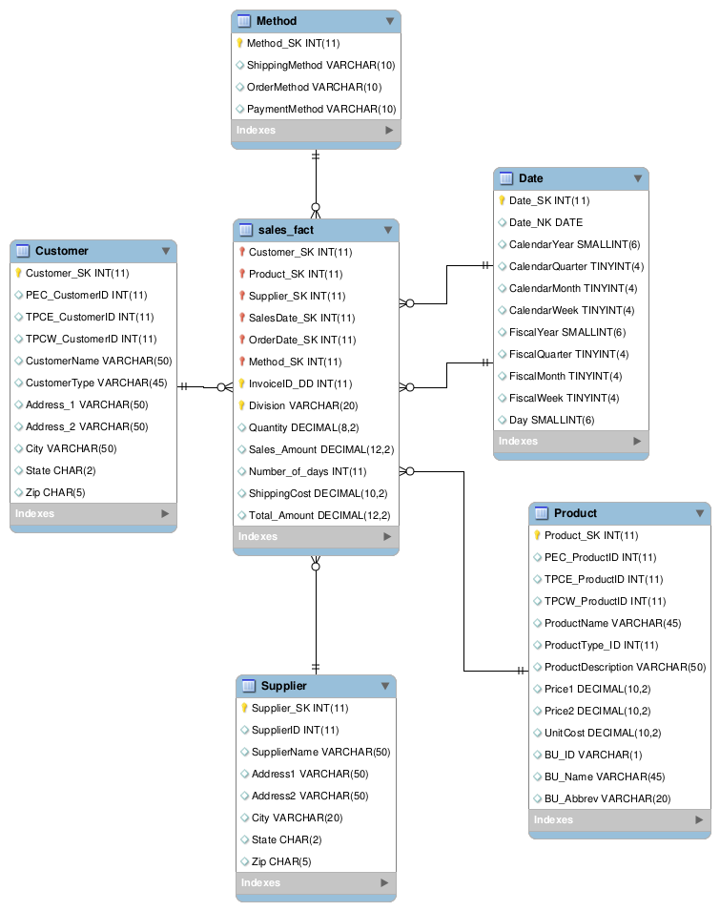

# 

# 

In this dimensional model, we have five dimensions: supplier, product, date, customer, and junk (method) dimensions. The sales_fact is a fact table that has calculated attributes such as total amount and quantity. also, it has degenerate dimension named invoiceID_DD and the grain will be at the lowest level of details of single sales among all divisions.

* Customer dimension
  + Attributes added in Customer dimension
    - PEC_CustomerID
    - TPCE_CustomerID
    - TPCW_CustomerID
* Attributes used from initial Customer dimension
  + CustomerName
  + CustomerType
  + Address_1
  + Address_2
  + City
  + State
  + Zip
* Attributes removed from initial Customer dimension
  + CustomerID
* Product dimension
  + Attributes added in Product dimension
    - PEC_ProductID
    - TPCE_ProductID
    - TPCW_ProductID
    - BU_ID
* Attributes used from initial Product dimension
  + Product_SK
  + ProductName
  + ProductType_ID
  + ProductDescription
  + Price1
  + Price2
  + BU_Name
  + BU_Abbrev
* Attributes removed from initial Product dimension
  + ProductID
* Supplier dimension
  + Attributes added in Supplier dimension
    - None of the attributes were added
* Attributes used from initial Supplier dimension
  + Supplier_SK
  + SupplierID
  + SupplierName
  + Address1
  + Address2
  + City
  + State
  + Zip
* Attributes removed from initial Supplier dimension
  + None of the attributes were removed
* Date dimension
  + Attributes added in Date dimension
    - None of the attributes were added
* Attributes used from initial Date dimension
  + Date_SK
  + Date_NK
  + CalendarYear
  + CalendarQuarter
  + CalendarMonth
  + CalendarWeek
  + FiscalYear
  + FiscalQuarter
  + FiscalMonth
  + FiscalWeek
  + Day
* Attributes removed from initial Date dimension
  + dayOfWeek
  + typeOfDay
* Method dimension



* Attributes added in Method dimension
  + None of the attributes were added
* Attributes used from initial Method dimension
  + Method_SK
  + ShippingMethod
  + OrderMethod
  + PaymentMethod
* Attributes removed from initial Method dimension
  + None of the attributes were removed
* Sales_Fact fact
  + Attributes added in Sales_Fact table
    - Sales_Amount
    - ShippingCost
* Attributes used from initial Sales_Fact table
  + Customer_SK
  + Product_SK
  + Supplier_SK
  + SalesDate_SK
  + OrderDate_SK
  + Method_SK
  + InvoiceID
  + Quantity
  + Number_Of_Days
* Attributes removed from initial Sales_Fact table
  + productCost
  + sellingCost

**Crows Foot Diagram:**

# 

Primary keys and relationships with cardinality and participation:

# 

* Dimension table : Customer_DIM

# 

Surrogate Key: Customer_SK

# 

Relationship: Sales_Fact

# 

Cardinality: 1 : N

# 

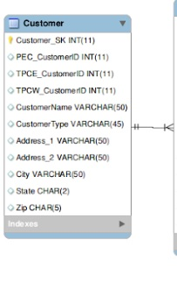

* Dimension table : Product_DIM

# 

Surrogate Key: Product_SK

# 

Relationship: Sales_Fact

# 

Cardinality: 1 : N

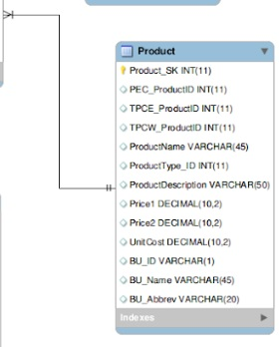

* Dimension table : Supplier_DIM

# 

Surrogate Key: Supplier_SK

# 

Relationship: Sales_Fact

# 

Cardinality: 1 : N

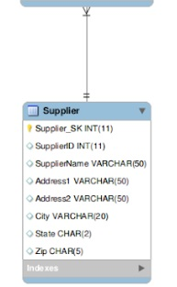

* Dimension table : Date_DIM

# 

Surrogate Key: Date_SK

# 

Relationship: Sales_Fact

# 

Cardinality: 1 : N

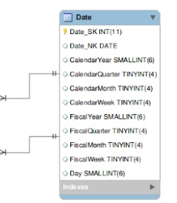

* Dimension table : Method_DIM

# 

Surrogate Key: Method_SK

# 

Relationship: Sales_Fact

# 

Cardinality: 1 : N

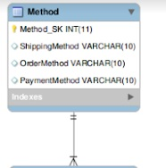

# III. Data Staging: ETL – Data Extract File Definitions

# 

|  |  |  |  |
| --- | --- | --- | --- |
| *Dimension* | *Source files* | | *Source Type* |
| *Customer Dimension* | *TPC-E* | *Customer* | *File (.csv)* |
| *Customer_type* | *File (.csv)* |
| *TPC-W* | *TPCWcustomer* | *File (.csv)* |
| *TPCWcustomer_type* | *File (.csv)* |
| *PEC* | *PECcustomer* | *File (.csv)* |
| *PECcustomer_type* | *File (.csv)* |
| *Junk Dimension* | *TPC-E* | *None* | *None* |
| *TPC-W* | *None* | *None* |
| *PEC* | *PECsales_new* | *File (.csv)* |
| *Product Dimension* | *TPC-E* | *Product* | *File (.csv)* |
|  | *prod_type* | *File (.csv)* |
| *Business_unit* | *File (.csv)* |
| *TPC-W* | *TPCWproduct* | *File (.csv)* |
| *TPCWproduct_type* | *File (.csv)* |
| *TPCWbusiness_unit* | *File (.csv)* |
| *PEC* | *PECproduct* | *File (.csv)* |
| *PECproduct_type* | *File (.csv)* |
| *PECbusiness_unit* | *File (.csv)* |
| *Supplier Dimension* | *TPC-E* | *Supplier* | *File (.csv)* |
| *TPC-W* | *TPCWProduct* | *File (.csv)* |
| *PEC* | *PECproduct* | *File (.csv)* |
| *Sales Fact* | *TPC-E* | *Invoice* | *File (.csv)* |
| *Invoice_details* | *File (.csv)* |
| *TPC-W* | *TPCWproduct*  *TPCWsales_new* | *File (.csv)* |
| *PEC* | *PECproduct*  *PECsales_new* | *File (.csv)* |
| *Date Dimension* | *TPC-E* | *Invoice* | *File (.csv)* |
| *TPC-W* | *TPCWsales_new* | *File (.csv)* |
| *PEC* | *PECsales_new* | *File (.csv)* |

# IV. Data Staging: ETL – Source-to-Target Mappings

Follow the same format as indicated in “The Data Warehouse ETL Toolkit” by Kimball & Caserta, Fig. 3.1 on page 60. This is available on Books 24x7. The table should be in alphabetical order table name and column name.

|  |  |  |  |  |  |  |  |  |  |
| --- | --- | --- | --- | --- | --- | --- | --- | --- | --- |
| Target | | | | | Source |  |  |  | Transformation |
| Table Name | Table Type | Column Name | Data Type | SCD Type | Database | Table Name | Column Name | Data Type |
|  |
| Customer | Dimension | PEC_CustomerID | Integer | 1 | TPCE | TPCE_Customer | CustomerID | String | Removed quotations mark, Rename the column name, Convert to Integer |
| Customer | Dimension | TPCE_CustomerID | Integer | 1 | TPCW | TPCW_Customer | CustomerID | String | Removed quotations mark, Rename the column name, Convert to Integer |
| Customer | Dimension | TPCW_CustomerID | Integer | 1 | PEC | PEC_Customer | CustomerID | Integer | Rename the column name |
| Customer | Dimension | Zip | Integer | 1 | TPCE | TPCE_Customer | Zip | String | Removed quotations mark, Rename the column name, Convert to Integer and Standard 5 Digit format |
| Customer | Dimension | Zip | Integer | 1 | TPCW | TPCW_Customer | Zip | String | Removed quotations mark, Rename the column name, Convert to Integer and Standard 5 Digit format |
| Customer | Dimension | Zip | Integer | 1 | PEC | PEC_Customer | Zip | Integer | Rename the column name, Convert to Standard 5 Digit format |
| Customer | Dimension | CustomerName | String | 1 | TPCE | TPCE_Customer | name | String | Removed quotations mark, Rename the column name, Recoded the inconsistent words like Inc, Co, Corp, Chem, Ga and De |
| Customer | Dimension | CustomerName | String | 1 | TPCW | TPCW_Customer | name | String | Removed quotations mark, Rename the column name, Recoded the inconsistent words like Inc, Co, Corp, Chem |
| Customer | Dimension | CustomerName | String | 1 | PEC | PEC_Customer | name | String | Rename the column name, Recoded the inconsistent words like Inc, Co, Corp, Chem |
| Customer | Dimension | CustomerType | String | 1 | TPCE | TPCE_Customer | custType | String | Removed quotations mark, Rename the column name, Recoded the inconsistent words like State/Local Gov, US Govt |
| Customer | Dimension | CustomerType | String | 1 | TPCW | TPCW_Customer | custType | String | Removed quotations mark, Rename the column name, Recoded the inconsistent words like Edu, State, Comm, Govt |
| Customer | Dimension | CustomerType | String | 1 | PEC | PEC_Customer | custType | String | Rename the column name, Recoded the inconsistent words like StatelocalGoverment,USGovt |
| Customer | Dimension | Address1 | String | 1 | TPCE | TPCE_Customer | ADDR | String | Removed quotations mark, Rename the column name, Split the Address to address1 and address 2. |
| Customer | Dimension | Address1 | String | 1 | TPCW | TPCW_Customer | ADDR | String | Removed quotations mark, Rename the column name, Split the Address to address1 and address 2. |
| Customer | Dimension | Address1 | String | 1 | PEC | PEC_Customer | ADDR | String | Rename the column name, Split the Address to address1 and address 2. |
| Customer | Dimension | Address2 | String | 1 | TPCE | TPCE_Customer | ADDR | String | Removed quotations mark, Rename the column name, Split the Address to address1 and address 2, Recoded the inconsistent words like Rd, St, Ave, Av, Dr. |
| Customer | Dimension | Address2 | String | 1 | TPCW | TPCW_Customer | ADDR | String | Removed quotations mark, Rename the column name, Split the Address to address1 and address 2, Recoded the inconsistent words like Rd, St, Ave, Av, Dr. |
| Customer | Dimension | Address2 | String | 1 | PEC | PEC_Customer | ADDR | String | Rename the column name, Recoded the inconsistent words like Rd, St, Ave, Av, Dr. |
| Customer | Dimension | City | String | 1 | TPCE | TPCE_Customer | city | String | Removed quotations mark, Rename the column name |
| Customer | Dimension | City | String | 1 | TPCW | TPCW_Customer | city | String | Removed quotations mark, Rename the column name |
| Customer | Dimension | City | String | 1 | PEC | PEC_Customer | city | String | Rename the column name |
| Customer | Dimension | State | String | 1 | TPCE | TPCE_Customer | state | String | Removed quotations mark, Rename the column name, Change to uppercase |
| Customer | Dimension | State | String | 1 | TPCW | TPCW_Customer | state | String | Removed quotations mark, Rename the column name, Change the State to its abbreviated form and Change a “Fl” to uppercase |
| Customer | Dimension | State | String | 1 | PEC | PEC_Customer | state | String | Rename the column name, Change to uppercase |
| Product | Dimension | PEC_ProductID | Integer | 1 | PEC | PEC_Product | ProdID | Integer | Rename the column name |
| Product | Dimension | TPCE_ProductID | Integer | 1 | TPCE | TPCE_Product | ProdID | Integer | Rename the column name |
| Product | Dimension | TPCW_ProductID | Integer | 1 | TPCW | TPCW_Product | ProdID | Integer | Rename the column name |
| Product | Dimension | ProductName | String | 1 | PEC | PEC_Product | Description | String | Rename the column name, Regex use to change equip |
| Product | Dimension | ProductName | String | 1 | TPCE | TPCE_Product | Description | String | Rename the column name, Regex use to change equip |
| Product | Dimension | ProductName | String | 1 | TPCW | TPCW_Product | Description | String | Rename the column name, Regex use to change equip |
| Product | Dimension | ProductTypeId | Integer | 1 | PEC | PEC_ProductType | ProductTypeId | Integer | Rename the column name |
| Product | Dimension | ProductTypeId | Integer | 1 | TPCE | TPCE_ProductType | ProductTypeId | Integer | Rename the column name |
| Product | Dimension | ProductTypeId | Integer | 1 | TPCW | TPCW_ProductType | ProductTypeId | Integer | Rename the column name |
| Product | Dimension | ProductDesc | String | 1 | PEC | PEC_ProductType | TypeDescription | String | Rename the column name, Regex use to change equip |
| Product | Dimension | ProductDesc | String | 1 | TPCE | TPCE_ProductType | TypeDescription | String | Rename the column name, Regex use to change equip |
| Product | Dimension | ProductDesc | String | 1 | TPCW | TPCW_ProductType | TypeDescription | String | Rename the column name, Regex use to change equip |
| Product | Dimension | Price1 | Integer | 1 | PEC | PEC_Product | Price1 | Integer | - |
| Product | Dimension | Price1 | Integer | 1 | TPCE | TPCE_Product | Price1 | Integer | - |
| Product | Dimension | Price1 | Integer | 1 | TPCW | TPCW_Product | Price1 | Integer | - |
| Product | Dimension | Price2 | Integer | 1 | PEC | PEC_Product | Price2 | Integer | - |
| Product | Dimension | Price2 | Integer | 1 | TPCE | TPCE_Product | Price2 | Integer | - |
| Product | Dimension | Price2 | Integer | 1 | TPCW | TPCW_Product | Price2 | Integer | - |
| Product | Dimension | UnitCost | Integer | 1 | PEC | PEC_Product | UnitCost | Integer | Rename the column name, Calcuated the Unit cost from Manfacture cost and quantity if the unit cost is null |
| Product | Dimension | UnitCost | Integer | 1 | TPCE | TPCE_Product | UnitCost | Integer | Rename the column name |
| Product | Dimension | UnitCost | Integer | 1 | TPCW | TPCW_Product | UnitCost | Integer | Rename the column name |
| Product | Dimension | BU_ID | String | 1 | PEC | PEC_BusinessUnit | BUID | String | Rename the column name, Trim the whitespace |
| Product | Dimension | BU_ID | String | 1 | TPCE | TPCE_BusinessUnit | BUID | String | Rename the column name, Trim the whitespace, Remove quotation mark |
| Product | Dimension | BU_ID | String | 1 | TPCW | TPCW_BusinessUnit | BUID | String | Rename the column name, Trim the whitespace, Remove quotation mark |
| Product | Dimension | BU_Name | String | 1 | PEC | PEC_BusinessUnit | Name | String | Rename the column name, Remove quotation mark |
| Product | Dimension | BU_Name | String | 1 | TPCE | TPCE_BusinessUnit | Name | String | Rename the column name, Remove quotation mark |
| Product | Dimension | BU_Name | String | 1 | TPCW | TPCW_BusinessUnit | Name | String | Rename the column name, Remove quotation mark |
| Product | Dimension | BU_Abbrev | String | 1 | PEC | PEC_BusinessUnit | Abbrev | String | Rename the column name, Remove quotation mark, Trim the whitespace, Replace Blank with null value |
| Product | Dimension | BU_Abbrev | String | 1 | TPCE | TPCE_BusinessUnit | Abbrev | String | Rename the column name, Remove quotation mark, Trim the whitespace, Replace Blank with null value |
| Product | Dimension | BU_Abbrev | String | 1 | TPCW | TPCW_BusinessUnit | Abbrev | String | Rename the column name, Remove quotation mark, Trim the whitespace, Replace Blank with null value |
| Supplier | Dimension | SupplierId | Integer | 1 | TPCE | TPCE_Supplier | SupplierID | String | Rename the column name, Remove quotation mark |
| Supplier | Dimension | SupplierName | String | 1 | PEC | PEC_Product | SupplierName | String | Rename the column name, Remove quotation mark, Replace the null value with PEC |
| Supplier | Dimension | SupplierName | String | 1 | TPCE | TPCE_Supplier | Name | String | Rename the column name, Remove quotation mark. Inc, Mo are inconsistent, used regex to change this. |
| Supplier | Dimension | SupplierName | String | 1 | TPCW | TPCW_Product | SupplierName | String | Used regex to change Inc, Mo to consistent format. |
| Supplier | Dimension | Address1 | String | 1 | TPCE | TPCE_Supplier | ADDR1 | String | Rename the column name, Remove quotation mark. Removed the “Attn” prefix from address1 |
| Supplier | Dimension | Address1 | String | 1 | TPCW | TPCW_Product | Address1 | String | Using regex to remove the prefix “Attn” |
| Supplier | Dimension | Address2 | String | 1 | TPCE | TPCE_Supplier | ADDR2 | String | Rename the column name, Remove quotation mark |
| Supplier | Dimension | Address2 | String | 1 | TPCW | TPCW_Product | Address2 | String | Change Some inconsistency like careless to carelessly etc. |
| Supplier | Dimension | City | String | 1 | TPCE | TPCE_Supplier | City | String | Rename the column name, Remove quotation mark |
| Supplier | Dimension | City | String | 1 | TPCW | TPCW_Product | City | String | Use regex to change ‘Talahassee’ to proper city name |
| Supplier | Dimension | State | String | 1 | TPCE | TPCE_Supplier | State | String | Rename the column name, Remove quotation mark |
| Supplier | Dimension | State | String | 1 | TCPW | TPCW_Product | State | String | Uppercase the state value to match consistent format |
| Supplier | Dimension | Zip | Integer | 1 | TPCE | TPCE_Supplier | Zip | String | Rename the column name, Remove quotation mark |
| Supplier | Dimension | Zip | Integer | 1 | TPCW | TPCW_Product | Zip | Integer | - |
| Method | Junk_Dimension | Shipping Method | String | 1 | PEC | PEC_sales_new | ShipMethod | String | Change the column name, change the value tuck to truck |
| Method | Junk_Dimension | PaymentMethod | String | 1 | PEC | PEC_sales_new | PaymentMethod | String | - |
| Method | Junk_Dimension | Order Method | String | 1 | PEC | PEC_sales_new | OrderMethod | String | - |
| Sales_fact | Fact | InvoiceID_DD | Integer | 1 | PEC | TPCEInvoice_details | invoiceID | Integer | Change the column name |
| Sales_fact | Fact | InvoiceID_DD | Integer | 1 | TPCE | PEC_sales_new | Invoice | Integer | Change the column name |
| Sales_fact | Fact | InvoiceID_DD | Integer | 1 | TPCW | TPCW_sales_new | Invoice | Integer | Change the column name |
| Sales_fact | Fact | Quantity | Integer | 1 | PEC | TPCEInvoice_details | qty | Integer | Change the column name |
| Sales_fact | Fact | Quantity | Integer | 1 | TPCE | PEC_sales_new | qty | Integer | Change the column name |
| Sales_fact | Fact | Quantity | Integer | 1 | TPCW | TPCW_sales_new | qty | Integer | Change the column name |
| Sales_fact | Fact | Sales_Amount | Integer | 1 | PEC | TPCEInvoice_details and TPCEProduct | Qty, price1, price2 | Integer | Change the column name, Calculated the Sales_amount by multiplying price1 * qty if discounted = 0 or else price2 * qty |
| Sales_fact | Fact | Sales_Amount | Integer | 1 | TPCE | PEC_sales_new and PECProduct | Qty, price1, price2 | Integer | Change the column name, Calculated the Sales_amount by multiplying price1 * qty if discounted = 0 or else price2 * qty |
| Sales_fact | Fact | Sales_Amount | Integer | 1 | TPCW | TPCW_sales_new and TPCWProduct | Qty, price1, price2 | Integer | Change the column name, Calculated the Sales_amount by multiplying price1 * qty if discounted = 0 or else price2 * qty |
| Sales_fact | Fact | NumberofDay | Integer | 1 | PEC | PEC_sales_new | Order date and Sales date | Date | Change the column name, We code this by Order date – Sales date. |
| Sales_fact | Fact | ShippingCost | Integer | 1 | PEC | PEC_sales_new | shipCost | Integer | Change the column name |

# V. SQL Code – Tables & Constraints

# CREATE DATABASE IF NOT EXISTS `Finance_DW` /*!40100 DEFAULT CHARACTER SET utf8 */;

# USE `Finance_DW`;

# -- MySQL dump 10.13 Distrib 5.7.21, for Linux (x86_64)

# --

# -- Host: 127.0.0.1 Database: Finance_DW

# -- ------------------------------------------------------

# -- Server version 5.7.21-0ubuntu0.16.04.1

# /*!40101 SET @OLD_CHARACTER_SET_CLIENT=@@CHARACTER_SET_CLIENT */;

# /*!40101 SET @OLD_CHARACTER_SET_RESULTS=@@CHARACTER_SET_RESULTS */;

# /*!40101 SET @OLD_COLLATION_CONNECTION=@@COLLATION_CONNECTION */;

# /*!40101 SET NAMES utf8 */;

# /*!40103 SET @OLD_TIME_ZONE=@@TIME_ZONE */;

# /*!40103 SET TIME_ZONE='+00:00' */;

# /*!40014 SET @OLD_UNIQUE_CHECKS=@@UNIQUE_CHECKS, UNIQUE_CHECKS=0 */;

# /*!40014 SET @OLD_FOREIGN_KEY_CHECKS=@@FOREIGN_KEY_CHECKS, FOREIGN_KEY_CHECKS=0 */;

# /*!40101 SET @OLD_SQL_MODE=@@SQL_MODE, SQL_MODE='NO_AUTO_VALUE_ON_ZERO' */;

# /*!40111 SET @OLD_SQL_NOTES=@@SQL_NOTES, SQL_NOTES=0 */;

# --

# -- Table structure for table `Customer`

# --

# DROP TABLE IF EXISTS `Customer`;

# /*!40101 SET @saved_cs_client = @@character_set_client */;

# /*!40101 SET character_set_client = utf8 */;

# CREATE TABLE `Customer` (

# `Customer_SK` int(11) NOT NULL,

# `PEC_CustomerID` int(11) DEFAULT NULL,

# `TPCE_CustomerID` int(11) DEFAULT NULL,

# `TPCW_CustomerID` int(11) DEFAULT NULL,

# `CustomerName` varchar(50) DEFAULT NULL,

# `CustomerType` varchar(45) DEFAULT NULL,

# `Address_1` varchar(50) DEFAULT NULL,

# `Address_2` varchar(50) DEFAULT NULL,

# `City` varchar(50) DEFAULT NULL,

# `State` char(2) DEFAULT NULL,

# `Zip` char(5) DEFAULT NULL,

# PRIMARY KEY (`Customer_SK`),

# KEY `Customer_SK` (`Customer_SK`)

# ) ENGINE=InnoDB DEFAULT CHARSET=utf8;

# /*!40101 SET character_set_client = @saved_cs_client */;

# --

# -- Table structure for table `Date`

# --

# DROP TABLE IF EXISTS `Date`;

# /*!40101 SET @saved_cs_client = @@character_set_client */;

# /*!40101 SET character_set_client = utf8 */;

# CREATE TABLE `Date` (

# `Date_SK` int(11) NOT NULL,

# `Date_NK` date DEFAULT NULL,

# `CalendarYear` smallint(6) DEFAULT NULL,

# `CalendarQuarter` tinyint(4) DEFAULT NULL,

# `CalendarMonth` tinyint(4) DEFAULT NULL,

# `CalendarWeek` tinyint(4) DEFAULT NULL,

# `FiscalYear` smallint(6) DEFAULT NULL,

# `FiscalQuarter` tinyint(4) DEFAULT NULL,

# `FiscalMonth` tinyint(4) DEFAULT NULL,

# `FiscalWeek` tinyint(4) DEFAULT NULL,

# `Day` smallint(6) DEFAULT NULL,

# PRIMARY KEY (`Date_SK`),

# KEY `Date_SK` (`Date_SK`)

# ) ENGINE=InnoDB DEFAULT CHARSET=utf8;

# /*!40101 SET character_set_client = @saved_cs_client */;

# --

# -- Table structure for table `Method`

# --

# DROP TABLE IF EXISTS `Method`;

# /*!40101 SET @saved_cs_client = @@character_set_client */;

# /*!40101 SET character_set_client = utf8 */;

# CREATE TABLE `Method` (

# `Method_SK` int(11) NOT NULL,

# `ShippingMethod` varchar(10) DEFAULT NULL,

# `OrderMethod` varchar(10) DEFAULT NULL,

# `PaymentMethod` varchar(10) DEFAULT NULL,

# PRIMARY KEY (`Method_SK`)

# ) ENGINE=InnoDB DEFAULT CHARSET=utf8;

# /*!40101 SET character_set_client = @saved_cs_client */;

# --

# -- Table structure for table `Product`

# --

# DROP TABLE IF EXISTS `Product`;

# /*!40101 SET @saved_cs_client = @@character_set_client */;

# /*!40101 SET character_set_client = utf8 */;

# CREATE TABLE `Product` (

# `Product_SK` int(11) NOT NULL,

# `PEC_ProductID` int(11) DEFAULT NULL,

# `TPCE_ProductID` int(11) DEFAULT NULL,

# `TPCW_ProductID` int(11) DEFAULT NULL,

# `ProductName` varchar(45) DEFAULT NULL,

# `ProductType_ID` int(11) DEFAULT NULL,

# `ProductDescription` varchar(50) DEFAULT NULL,

# `Price1` decimal(10,2) DEFAULT NULL,

# `Price2` decimal(10,2) DEFAULT NULL,

# `UnitCost` decimal(10,2) DEFAULT NULL,

# `BU_ID` varchar(1) DEFAULT NULL,

# `BU_Name` varchar(45) DEFAULT NULL,

# `BU_Abbrev` varchar(20) DEFAULT NULL,

# PRIMARY KEY (`Product_SK`)

# ) ENGINE=InnoDB DEFAULT CHARSET=utf8;

# /*!40101 SET character_set_client = @saved_cs_client */;

# --

# -- Table structure for table `Supplier`

# --

# DROP TABLE IF EXISTS `Supplier`;

# /*!40101 SET @saved_cs_client = @@character_set_client */;

# /*!40101 SET character_set_client = utf8 */;

# CREATE TABLE `Supplier` (

# `Supplier_SK` int(11) NOT NULL,

# `SupplierID` int(11) DEFAULT NULL,

# `SupplierName` varchar(50) DEFAULT NULL,

# `Address1` varchar(50) DEFAULT NULL,

# `Address2` varchar(50) DEFAULT NULL,

# `City` varchar(20) DEFAULT NULL,

# `State` char(2) DEFAULT NULL,

# `Zip` char(5) DEFAULT NULL,

# PRIMARY KEY (`Supplier_SK`)

# ) ENGINE=InnoDB DEFAULT CHARSET=utf8;

# /*!40101 SET character_set_client = @saved_cs_client */;

# --

# -- Table structure for table `sales_fact`

# --

# DROP TABLE IF EXISTS `sales_fact`;

# /*!40101 SET @saved_cs_client = @@character_set_client */;

# /*!40101 SET character_set_client = utf8 */;

# CREATE TABLE `sales_fact` (

# `Customer_SK` int(11) NOT NULL,

# `Product_SK` int(11) NOT NULL,

# `Supplier_SK` int(11) NOT NULL,

# `SalesDate_SK` int(11) NOT NULL,

# `OrderDate_SK` int(11) NOT NULL,

# `Method_SK` int(11) NOT NULL,

# `InvoiceID_DD` int(11) NOT NULL,

# `Division` varchar(20) NOT NULL,

# `Quantity` decimal(8,2) DEFAULT NULL,

# `Sales_Amount` decimal(12,2) DEFAULT NULL,

# `Number_of_days` int(11) DEFAULT NULL,

# `ShippingCost` decimal(10,2) DEFAULT NULL,

# `Total_Amount` decimal(12,2) DEFAULT NULL,

# PRIMARY KEY (`InvoiceID_DD`,`Division`,`Customer_SK`,`SalesDate_SK`,`Supplier_SK`,`Method_SK`,`Product_SK`,`OrderDate_SK`),

# KEY `method_fk` (`Method_SK`),

# KEY `orderDate_fk` (`OrderDate_SK`),

# KEY `prod_fk` (`Product_SK`),

# KEY `salesDate_fk` (`SalesDate_SK`),

# KEY `supplier_fk` (`Supplier_SK`),

# KEY `Customer_SK` (`Customer_SK`,`SalesDate_SK`,`Supplier_SK`,`Method_SK`,`Product_SK`,`OrderDate_SK`),

# CONSTRAINT `cust_fk` FOREIGN KEY (`Customer_SK`) REFERENCES `Customer` (`Customer_SK`) ON DELETE NO ACTION ON UPDATE NO ACTION,

# CONSTRAINT `method_fk` FOREIGN KEY (`Method_SK`) REFERENCES `Method` (`Method_SK`) ON DELETE NO ACTION ON UPDATE NO ACTION,

# CONSTRAINT `orderDate_fk` FOREIGN KEY (`OrderDate_SK`) REFERENCES `Date` (`Date_SK`) ON DELETE NO ACTION ON UPDATE NO ACTION,

# CONSTRAINT `prod_fk` FOREIGN KEY (`Product_SK`) REFERENCES `Product` (`Product_SK`) ON DELETE NO ACTION ON UPDATE NO ACTION,

# CONSTRAINT `salesDate_fk` FOREIGN KEY (`SalesDate_SK`) REFERENCES `Date` (`Date_SK`) ON DELETE NO ACTION ON UPDATE NO ACTION,

# CONSTRAINT `supplier_fk` FOREIGN KEY (`Supplier_SK`) REFERENCES `Supplier` (`Supplier_SK`) ON DELETE NO ACTION ON UPDATE NO ACTION

# ) ENGINE=InnoDB DEFAULT CHARSET=utf8;

# /*!40101 SET character_set_client = @saved_cs_client */;

# /*!40103 SET TIME_ZONE=@OLD_TIME_ZONE */;

# /*!40101 SET SQL_MODE=@OLD_SQL_MODE */;

# /*!40014 SET FOREIGN_KEY_CHECKS=@OLD_FOREIGN_KEY_CHECKS */;

# /*!40014 SET UNIQUE_CHECKS=@OLD_UNIQUE_CHECKS */;

# /*!40101 SET CHARACTER_SET_CLIENT=@OLD_CHARACTER_SET_CLIENT */;

# /*!40101 SET CHARACTER_SET_RESULTS=@OLD_CHARACTER_SET_RESULTS */;

# /*!40101 SET COLLATION_CONNECTION=@OLD_COLLATION_CONNECTION */;

# /*!40111 SET SQL_NOTES=@OLD_SQL_NOTES */;

# -- Dump completed on 2018-05-04 18:44:35VI. Data Staging Activities - ETL

## **1. Data Cleansing**

|  |  |  |  |
| --- | --- | --- | --- |
| **DM Table** | **Attribute** | **Problem** | **Resolution Strategy** (attach code) |
| TPCWCustomer | custtype | Edu, State, Comm, Govt are not in abbreviated form | We use regex to change this to proper format such as Education, Commercial etc.. **Refer to Figure 1.** |
|  | name | Inc, Co, Corp, Chem, llc are inconsistent | We use regex to change this to proper format such as Incorporated, Company, Corporation etc.  **Refer to figure 2.** |
|  | address | Rd, St, Ave, Av, Dr, ‘,’, ‘.’ are inconsistent | We use regex to change the value to proper form such as Road, Street, Avenue, Drive and removed ‘,’ and ‘.’.  **Refer to figure 3.** |
|  | address | There was only 1 address field ( They were combined )    values had quotation marks. | We Split the Address using Split field. Address Like “Dept #805, 1977 Symbiotic Turnpike” was change to Address 1 : Dept #805 and Address 2 : 1977 Symbiotic Turnpike)    removed quotations marks.  **Refer to Figure 1.** |
|  | state | State Name was not in Abbreviation Format | We Change the State full name to its proper Abbreviated Format ( New York to NY) using replace in string method  **Refer to figure 4.** |
|  | state | In State ‘L’ was in lowercase in “Fl” | We change that to “FL” using replace in string method  **Refer to figure 4.** |
|  | zip | All the value of the zip was not 5 digit | We change them to a Standard 5 digit Format ( Example 7066 to 07066)  **Refer to figure 5.** |
|  | CustID | Inconsistent name ‘CustID’  values had quotation marks. | Rename to TPCW_CustomerID  removed quotations marks.  **Refer to figure 6.** |
|  | name | Inconsistent name ‘name’  values had quotation marks. | Rename to Name  removed quotations marks.  **Refer to figure 6.** |
|  | custType | Inconsistent name ‘custType’  values had quotation marks. | Rename to CustTypeName  removed quotations marks.  **Refer to figure 6.** |
|  | city | Inconsistent name ‘city’  values had quotation marks. | Rename to City  removed quotations marks.  **Refer to figure 6.** |
|  | state | Inconsistent name ‘state’  values had quotation marks. | Rename to State  removed quotations marks.  **Refer to figure 6.** |
|  | zip | Inconsistent name ‘zip’  values had quotation marks. | Rename to Zip.  removed quotations marks.  **Refer to figure 6.** |
| TPCWProduct | ProductID | column name was not present  values had quotation marks. | Added column name.  removed quotations marks.  **Refer to figure 7, & figure 9.** |
|  | Productname | column name was not present  values had quotation marks.  Equip was presented inconsistent format. | Added column name.  removed quotations marks.  regex used to change Equip in correct from.  **Refer to figure 7, figure 8 & figure 9.** |
|  | Price1 | column name was not present  values had quotation marks. | Added column name.  removed quotations marks.  **Refer to figure 7, & figure 9.** |
|  | Price2 | column name was not present  values had quotation marks. | Added column name.  removed quotations marks.  **Refer to figure 7, & figure 9.** |
|  | UnitCost | column name was not present  values had quotation marks. | Added column name.  removed quotations marks.  **Refer to figure 7, & figure 9.** |
|  | SupplierName | column name was not present  values had quotation marks.  Inc was presented inconsistent format. | Added column name.  removed quotations marks.  regex used to change Inc in correct form.  **Refer to figure 7, figure 8, & figure 9.** |
|  | SupplierAddress1 | column name was not present  values had quotation marks.  was separated from supplier address2.  “Attn :” were presented. | Added column name.  removed quotations marks.  column combined with supplieraddress2.  removed “Attn :” values.  **Refer to figure 7, figure 8, & figure 9.** |
|  | SupplierAddress2 | column name was not present  values had quotation marks.  was separated from | Added column name.  removed quotations marks.  column combined with supplieraddress1.  **Refer to figure 7, & figure 9.** |
|  | SupplierCity,& SupplierState | column name was not present  values had quotation marks.  state and city were in the same column. | Added column name.  removed quotations marks.  state and city were separated into two different columns.  **Refer to figure 7, & figure 9.** |
|  | SupplierZipcode | column name was not present  values had quotation marks. | Added column name.  removed quotations marks  **Refer to figure 7, & figure 9**. |
|  | ProductTypeID | column name was not present  values had quotation marks. | Added column name.  removed quotations marks  **Refer to figure 7, & figure 9**. |
|  | Product Name | Two Duplicate Product were Present i.e., Optima Cleaning Supplies and Measured Photo Chemicals | We remove the duplicate value **Refer to figure 10**. |
|  | Address2 | St, Ave, Careless, 6027 and 3737 were inconsistent | We replace them by Street, Avenue, Carelessly, 6037 and 3727 respectively **Refer to figure 11**. |
|  | City | The spelling of ‘Talahassee’ was wrong | We change it to ‘Tallahassee’ **Refer to figure 11.** |
| TPCWProduct_type | PRODTYPEID | quotation mark was presented.  column name was inconsistent format.  zeros were presented prior product id. | removed quotation marks.  renamed column name.  converted product id to integer to take care of zeros **Refer to figure 12**. |
|  | TYPEDESCRIPTION | quotation mark was presented.  column name was inconsistent format. | removed quotation marks.  renamed column name **Refer to figure 12**. |
|  | BUID | quotation mark was presented.  column name was inconsistent format. | removed quotation marks.  renamed column name **Refer to figure 12**. |
| TPCWsales_new | salesDate | salesDate was in dd-MM-yy | Converted to standard yyyy/MM/dd format.  **Refer to figure 13**. |
|  | salesDate | salesDate was in MM/dd/yyyy format | Converted to standard yyyy/MM/dd format.  **Refer to figure 14**. |
|  | salesDate | For invoiceID 26511 most of the data were junk(just names) | Deleted the record as it does not consist of any information.  **Refer to figure 15**. |
|  | custID | Similarly for invoiceID 19061 custID was -1, 14710 invalid custID 41( no data was present for customer) | Removed record.  **Refer to figure 16**. |
|  | salesDate | Record number 4881 has date 20-08-05372 | Converted to 08/20/05 and later converted to standard format of yyyyMMdd.  **Refer to figure 17**. |
|  | salesDate | Record number 42815 has a cell value salesDate | Inserted null in the cell in place of saleDate.  **Refer to figure 17**. |
| TPCWbusiness_unit | ABBREV | null value were presented. | replaced it with not available value.  **Refer to figure 18**. |
| TPCECustomer | NAME | Inc, Co, Corp, Chem, llc are inconsistent | We use regex to change this to proper format such as Incorporated, Company, Corporation etc.  **Refer to figure 19**. |
|  | NAME | Short forms like ‘Ga’ and ‘De’ were used | We replace them to Georgia and Delaware using replace in string method.  **Refer to figure 19**. |
|  | ZIP | All the value of the zip was not 5 digit | We change them to a Standard 5 digit Format ( Example 778 to 00778).  **Refer to figure 5**. |
|  | CUSTID | Inconsistent name ‘CUSTID’  values had quotation marks. | Rename to TPCE_CustomerID  removed quotation marks  **Refer to figure 20, & figure 21**. |
|  | ADDR1 | Inconsistent name ‘ADDR1’  values had quotation marks. | Rename to Address1  removed quotation marks.  **Refer to figure 20, & figure 21**. |
|  | ADDR2 | Inconsistent name ‘ADDR2’  values had quotation marks. | Rename to Address2  removed quotation marks  **Refer to figure 20, & figure 21**. |
|  | NAME | Inconsistent name ‘NAME’  values had quotation marks. | Rename to Name  removed quotation marks.  **Refer to figure 20, & figure 21**. |
|  | CITY | Inconsistent name ‘CITY’  values had quotation marks. | Rename to City  removed quotation marks  **Refer to figure 20, & figure 21**. |
|  | STATE | Inconsistent name ‘STATE’  values had quotation marks. | Rename to State  removed quotation marks  **Refer to figure 20, & figure 21** |
|  | ZIP | Inconsistent name ‘ZIP’  values had quotation marks. | Rename to Zip  removed quotation marks  **Refer to figure 20, & figure 21** |
| TPCECustomer_type | TYPENAME | State/Local Gov, US Govt are not in proper abbreviated form  values had quotation marks. | We use regex to change this to proper format such as State/Local Government and US Government.  removed quotation marks.  **Refer to figure 22.** |
|  | TYPENAME | Inconsistent name ‘TYPENAME’  values had quotation marks. | Rename to custTypeName.      removed quotation marks.  **Refer to figure 21** |
| TPCEInvoice | salesDate | Not in standard format as we want | Modified to standard format of yyyy/MM/dd.  **Refer to figure 23** |
|  | custID | Inconsistent name | Rename to CustomerID  **Refer to figure 24** |
|  | invoiceID | Inconsistent name | Rename to InvoiceID  **Refer to figure 24** |
| TPCEproduct | DESCRIPTION | Equip represented in inconsistent form. | regex used to change Equip in correct form **Refer to figure 25** . |
| TPCEproduct_type | TypeDescription | Equip represented in inconsistent form. | regex used to change Equip in correct form **Refer to figure 25.**. |
| TPCEsupplier | NAME | Inc, Ag and Mo are inconsistent | We use regex to change this to proper format such as Incorporated, Agency and Missouri.  **Refer to figure 26** |
|  | Name | Incorporated. (dot is present) | dot is remove  **Refer to figure 26** |
|  | ADDR1 | ‘Attn : ‘ was in the Address1 Field | We removed the ‘Attn :’ from address field using replace in string and regex  **Refer to figure 26** |
|  | ADDR2 | ‘St’ name was not consistent | Renamed to Street  **Refer to figure 26** |
|  | ADDR2 | ‘Ave’ name was not consistent | Renamed to Avenue  **Refer to figure 26** |
|  | SupplierID | Inconsistent name ‘SUPPLIERID’ | Rename it to SupplierID  **Refer to figure 27** |
|  | Name | Inconsistent name ‘NAME’ | Rename it to SupplierName  **Refer to figure 27** |
|  | ADDR1 | Inconsistent name ADDR1 | Rename it to Address1  **Refer to figure 27** |
|  | ADDR2 | Inconsistent name ADDR2 | Rename it to Address2  **Refer to figure 27** |
|  | CITY | Inconsistent name CITY | Rename it to City  **Refer to figure 27** |
|  | STATE | Inconsistent name STATE | Rename it to State  **Refer to figure 27** |
|  | ZIP | Inconsistent name ZIP | Rename it to Zip  **Refer to figure 27** |
| TPCEbusiness_unit | ABBREV | null values were presented. | replaced it with not available value **Refer to figure 18**. |
| PECCustomer | name | Inc, Co, Corp, Chem, llc are inconsistent | We use regex to change this to proper format such as Incorporated, Company, Corporation etc.  **Refer to figure 29.** |
|  | zip | All the value of the zip was not 5 digit | We change them to a Standard 5 digit Format ( Example 7066 to 07066)  **Refer to figure 5** |
|  | address | Rd, St, Ave, Av, Dr, ‘,’, ‘.’ are inconsistent | We use regex to change the value to proper form such as Road, Street, Avenue, Drive and removed ‘,’ and ‘.’  **Refer to figure 31** |
|  | address | There was only 1 address field ( They were combined ) | We Split the Address using Split field. Address Like “Dept #805, 1977 Symbiotic Turnpike” was change to Address 1 : Dept #805 and Address 2 : 1977 Symbiotic Turnpike)  **Refer to figure 28,** |
|  | Customer Type | StatelocalGoverment, USGovt are not in proper abbreviated form | We use regex to change this to proper format such as State/Local Government and US Government. **Refer to figure 30** |
|  | CustID | Inconsistent name ‘CustID’ | Rename to PEC_CustomerID  **Refer to figure 21** |
|  | name | Inconsistent name ‘name’ | Rename to Name  **Refer to figure 32** |
|  | custType | Inconsistent name ‘custtype’ | Rename to CustTypeName  **Refer to figure 32** |
|  | city | Inconsistent name ‘city’ | Rename to City  **Refer to figure 32** |
|  | state | Inconsistent name ‘state’ | Rename to State  **Refer to figure 32** |
|  | zip | Inconsistent name ‘zip’ | Rename to Zip  **Refer to figure 32** |
| PECBusiness_unit | Abbrev | Has null values. | replace it with not available  **Refer to figure 18.** |
| PECManufacture_cost | Year | Single digit such as 5,6 etc. | converted to standard format like 5 is converted to 2005.  **Refer to figure 33.** |
|  | prodID | Non standard/inconsistent name | Converted to ProductID  **Refer to figure 34** |
|  | manufacturingCost | Non standard/inconsistent name | Convert to ManufacturingCost  **Refer to figure 34** |
| PECProduct | prodid | quotation marks were presented. | quotation marks has been removed **Refer to figure 35**. |
|  | prodDescription | quotation marks were presented.  Equip represented in inconsistent form. | quotation marks were removed.  regex used to change Equip in correct form **Refer to figure 35**. |
|  | supplierName | quotation marks were presented.  some values were null. | quotation marks has been removed.  null values were changed to PEC **Refer to figure 35, figure 36**. |
|  | productTypeID | quotation marks were presented. | quotation marks has been removed **Refer to figure 35**. |
|  | unitCost | Inconsistent name.  some rows were null. | Rename to UnitCost.  unitCost was calculated using manufacture cost and product quantity **Refer to figure 37**. |
| PECProduct_type | TYPEDESCRIPTION | quotation marks were presented.  Equip represented in inconsistent form.  column name had quotation mark. | quotation marks has been removed.  regex used to change Equip in correct form **Refer to figure 38, & figure 39**. |
|  | PRODTYPEID | column name had quotation mark. | quotation mark has been removed **Refer to figure 38, & figure 39** . |
|  | BUID | column name had quotation mark. | replaced column name **Refer to figure 38, & figure 39**. |
| PECSales_new | orderDate | Inconsistent date format | Converted to standard date format yyyy/MM/dd  **Refer to figure 40** |
|  | salesDate | Inconsistent date format | Converted to standard date format yyyy/MM/dd  **Refer to figure 40** |
|  | custID | Inconsistent name | Renamed to CustomerID  **Refer to figure 41** |
|  | discounted | Inconsistent name | Renamed to Discounted  **Refer to figure 41** |
|  | orderMethod | Inconsistent name | Renamed to OrderMethod  **Refer to figure 41** |
|  | paymentMethod | Inconsistent name | Renamed to PaymentMethod  **Refer to figure 41** |
|  | prodid | Inconsistent name | Renamed to ProductID  **Refer to figure 41** |
|  | qty | Inconsistent name | Renamed to Quantity  **Refer to figure 41** |
|  | shipCost | Inconsistent name | Renamed to ShipCost  **Refer to figure 41** |
|  | shipMethod | Inconsistent name | Rename to ShipMethod  **Refer to figure 41** |
|  | amt | Inconsistent name | Rename to Amount  **Refer to figure 41** |
|  | salesDate | Record 111 has a date ‘200805-16’,which is not in any standard format | Converted to 2008/05/16 in excel spreadsheet.  **Refer to figure 42** |
|  | custID | Record number 20000 has 33,2009-04-01” in customerID field, which is concatenated string of custID and salesDate | Splitted custID and sales date and moved all other attributes to the correct cell.  **Refer to figure 43** |
|  | Invoice | Record number 41002 has a Invoice column in the format 0000025563"11, which consist of invoice number as well as custID. | splitted Invoice to Invoice and custID field and moved all other attributes to the correct cell.  **Refer to figure 43** |
|  | shipMethod | Misspelled truck as tuck | Renamed tuck to truck.  **Refer to figure 44** |

**Figures:**

**Figure 1:** Used regular expression to reformat custtype and address.

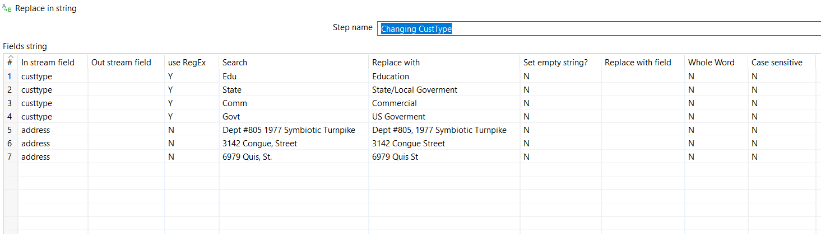

**Figure 2:** Name Inc, Co, Corp, Chem, llc converted to Incorporated, Company, Corporation, Chemicals, and limited liability company.

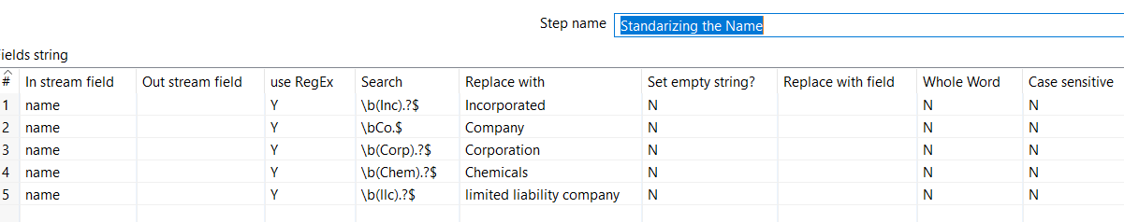

**Figure 3:** Address Rd, St, Ave, Av, Dr updated through regex.

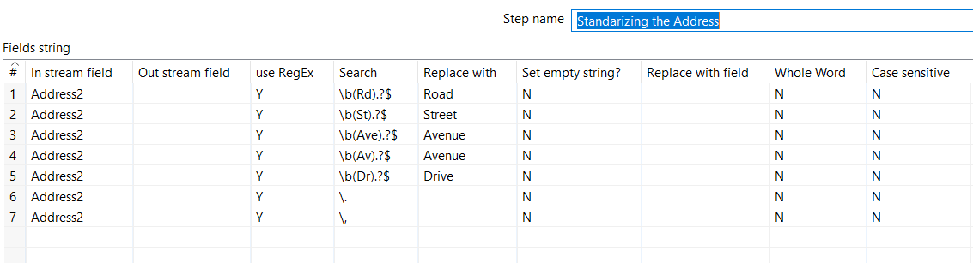

**Figure 4:** Modified state to standard name such as AK to Alaska.

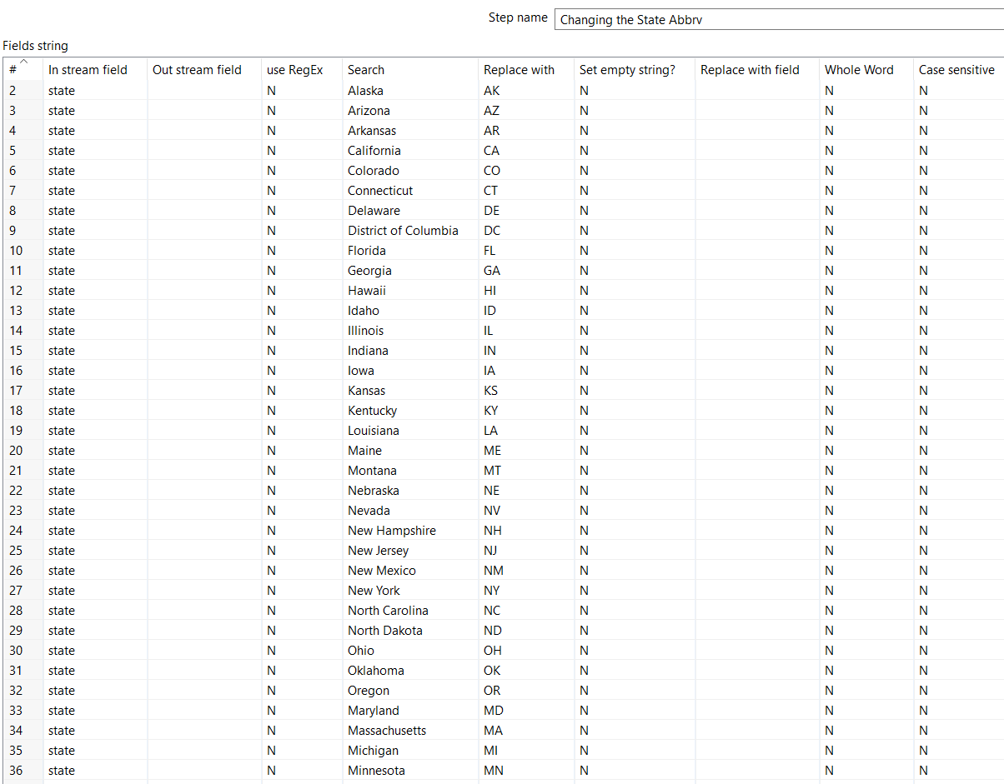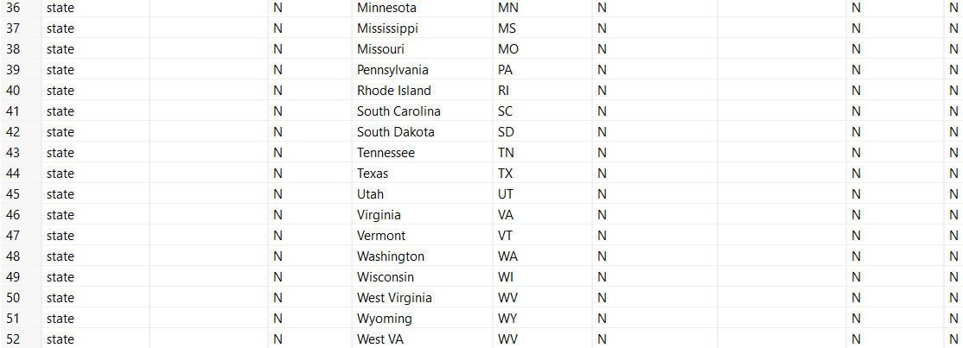

**Figure 5:** Converted zip to standard 5 digits format.

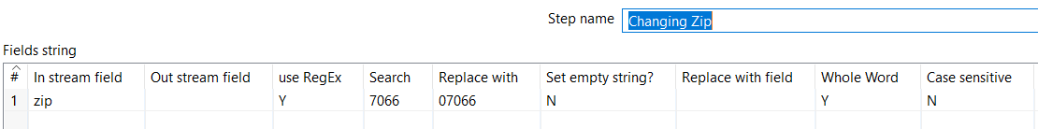

**Figure 6:** Rename fields to standard format.

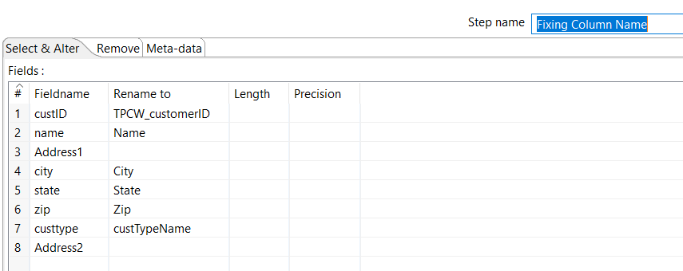

**Figure 7:** Added the column name

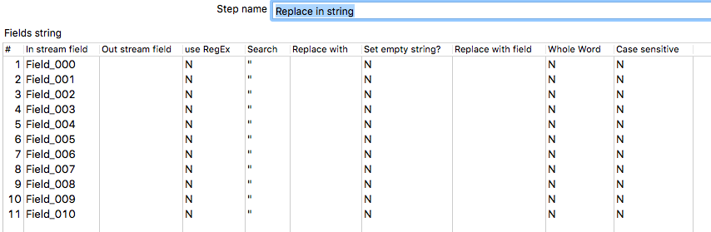

**Figure 8:** Changes Equip to Equipment, Inc to Incorporated, removed Attn: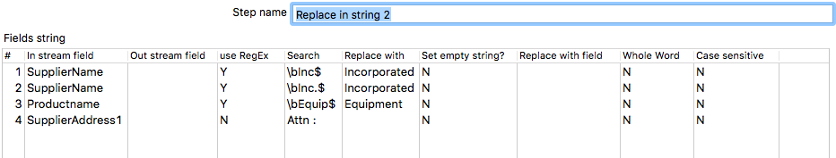

**Figure 9:** Removed quotation

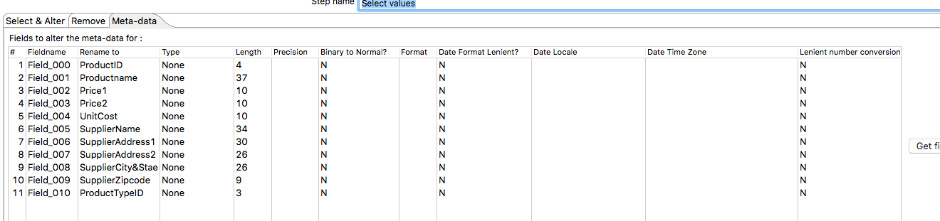

**Figure 10:** Removed duplicate product

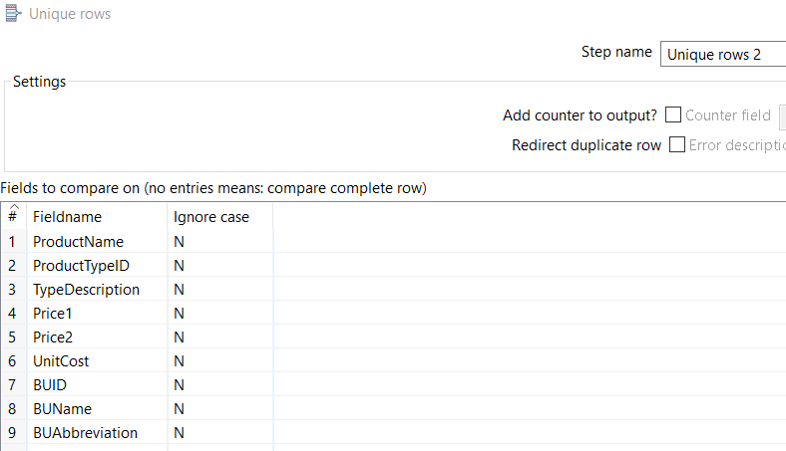

**Figure 11:** St, Ave, Careless, 6027, 3737 modified to street, Avenue, Carelessly, 6037, and 3727. Also changed the city name from ‘Talahassee’ to ‘Tallahassee’.

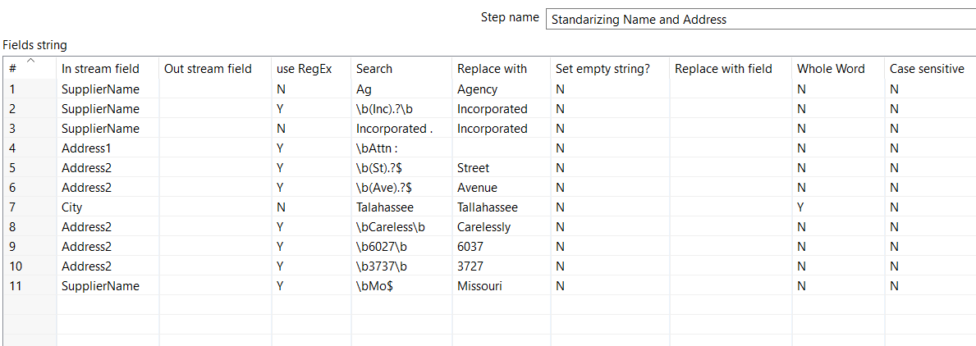

**Figure 12:** Remove quotation.

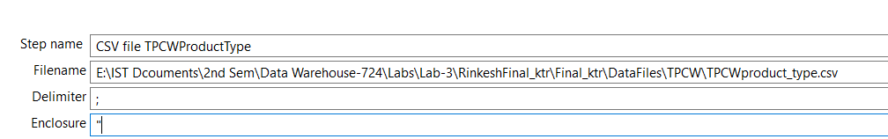

**Figure 13:** Convert to standard date format

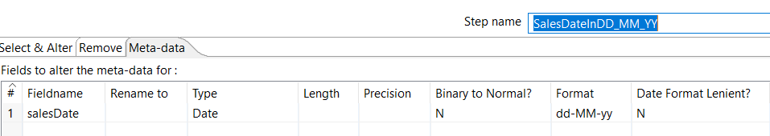

**Figure 14:** Convert salesDate to standard date format.

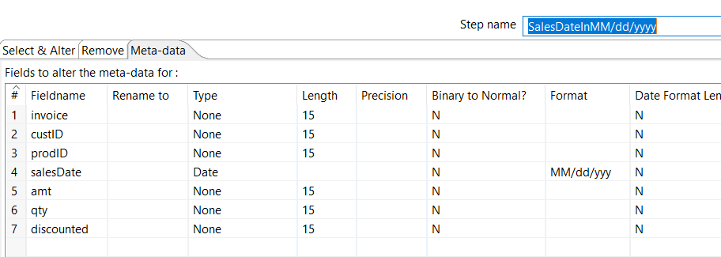

**Figure 15:** Removed junk row

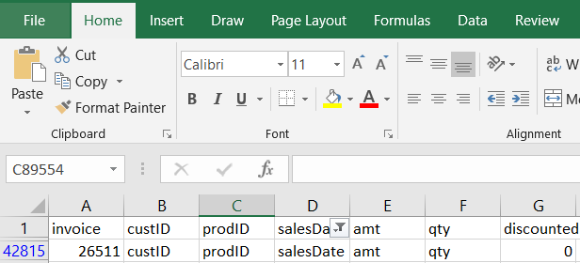

**Figure 16:** Removed row having customerID -1, 41, and custID

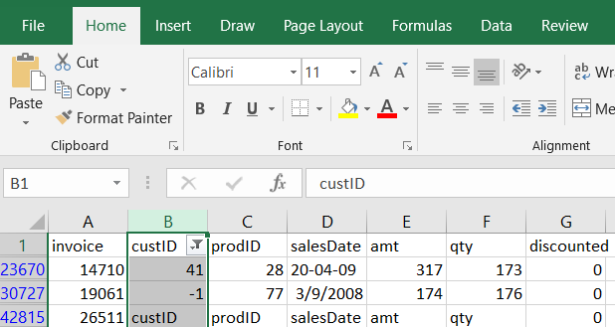

**Figure 17:** Modified date 20-08-05372 to 08/20/05 and from value salesDate to null.

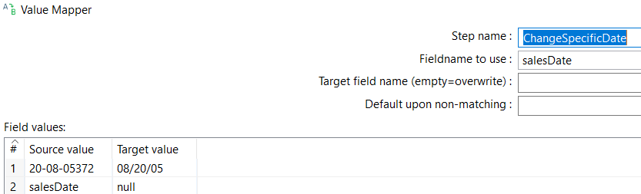

**Figure 18:** Replace ABBREV to Not Available

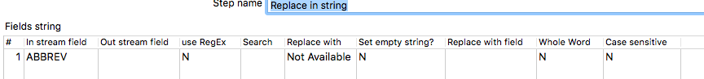

**Figure 19:** Rename fields using regular expression

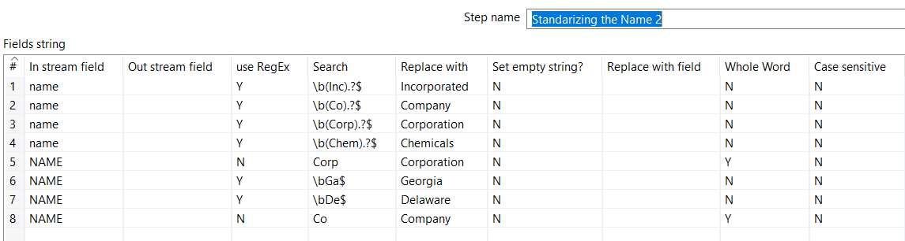

**Figure 20:** Remove quotations.

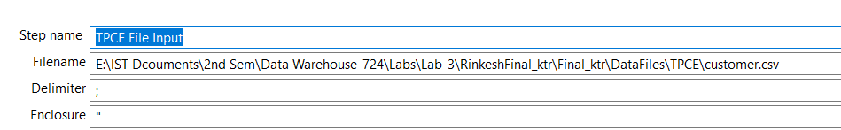

**Figure 21:** Rename field to standard format.

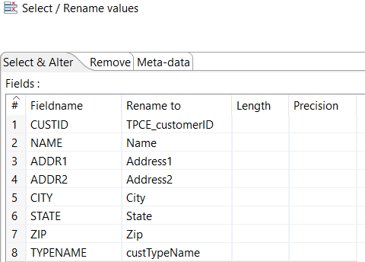

**Figure 22:** Modified TypeName from State/Local Gov to State/Local Government.

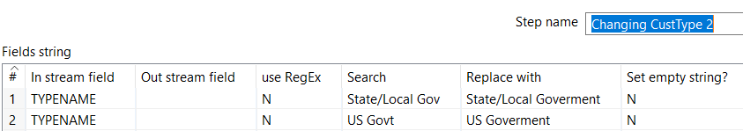

**Figure 23:** Modified date format.

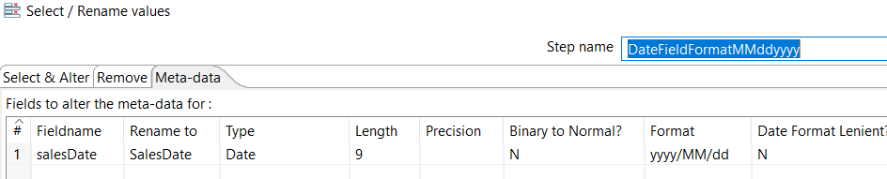

**Figure 24:** Modified custID and invoice to standard format.

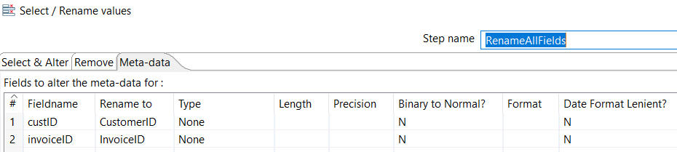

**Figure 25:** Modified Equip to Equipment

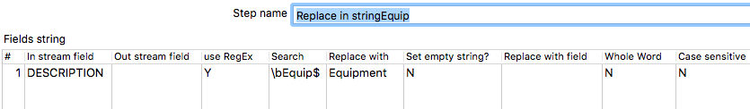

**Figure 26:** Used regex to change the name and address.

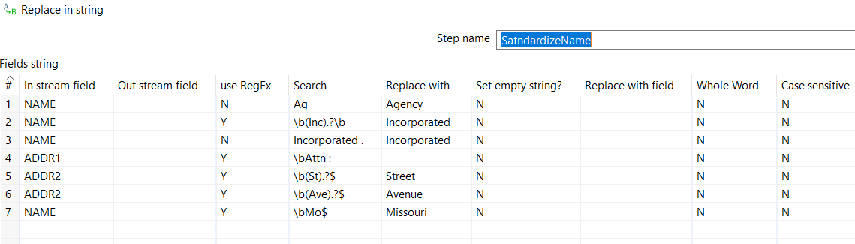

**Figure 27:** Rename fields to maintain consistency.

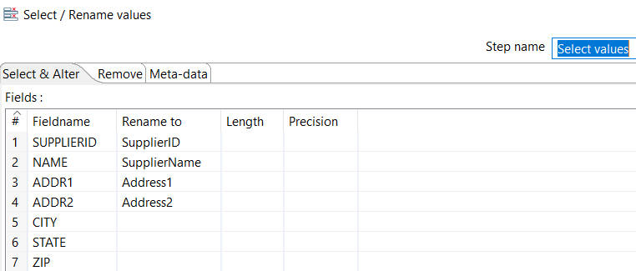

**Figure 28:** Used regular expression to change the field.

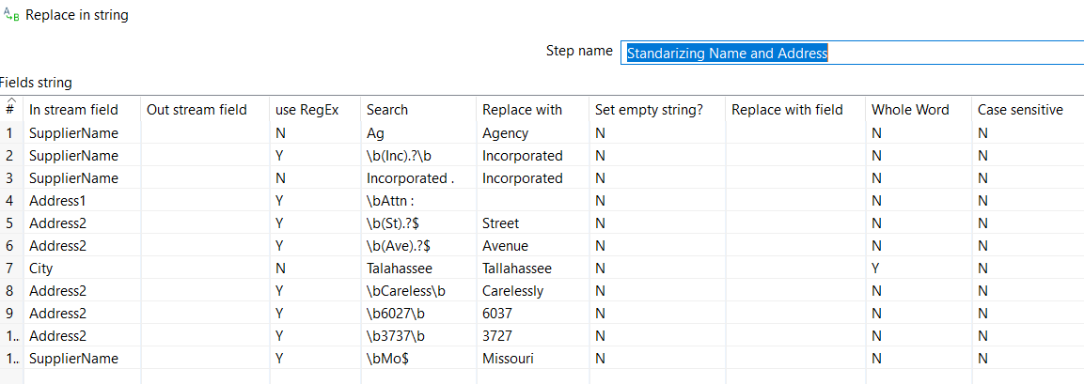

**Figure 29:** Using regular expression to modify Inc. and Co.

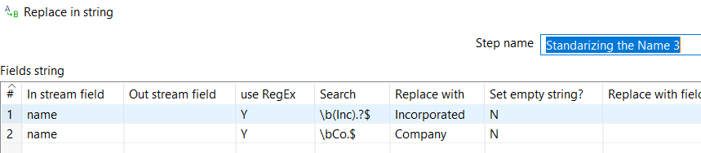

**Figure 30:** Modified custtype.

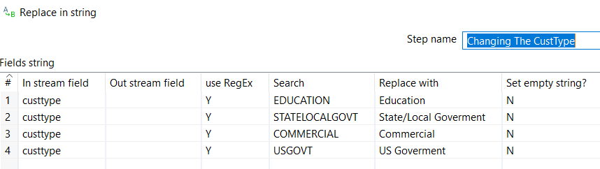

**Figure 31:** Using regular expression to address.

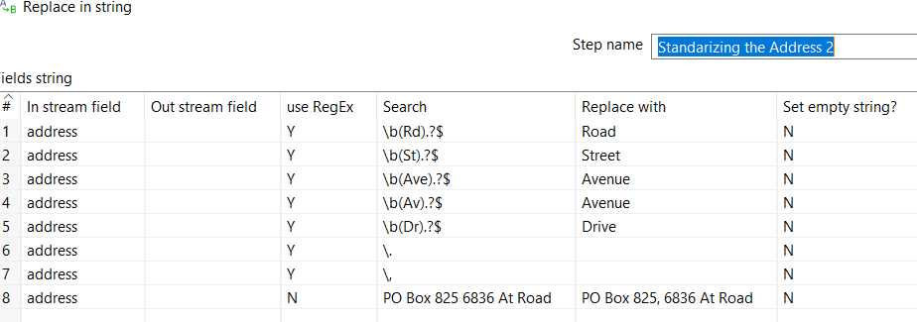

**Figure 32:** Using standard name

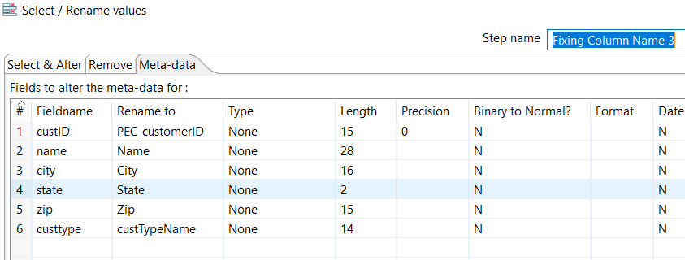

**Figure 33:** Modified year from y to yyyy format.

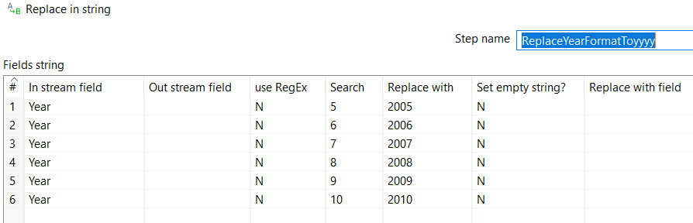

**Figure 34:** Modified name.

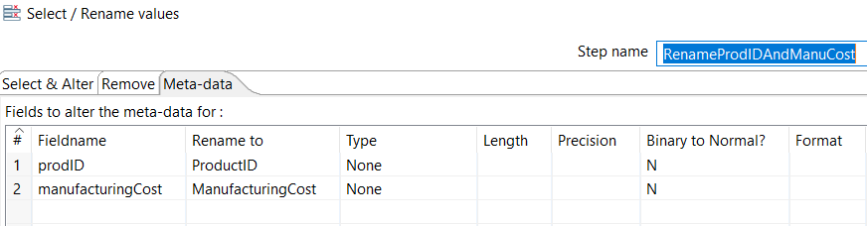

**Figure 35:** Updated field name from Equip to Equipment.

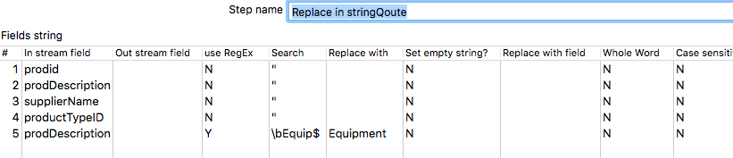

**Figure 36:** Update supplierName to PEC if its’ null.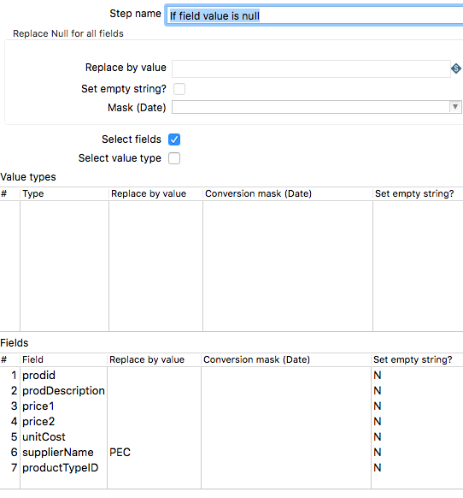

**Figure 37:** Calculate unit cost

**Figure 38:** Rename field value.

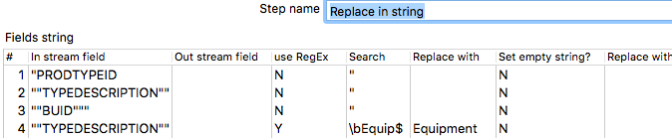

**Figure 39:** Rename field PRODTYPEID, TypeDescription, BUID to standard name.

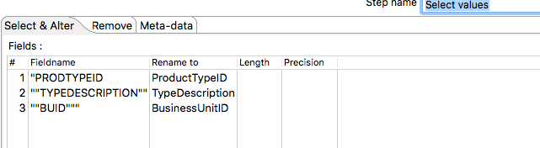

**Figure 40:** changed the orderDate and salesDate to standard date format yyyy/MM/dd.

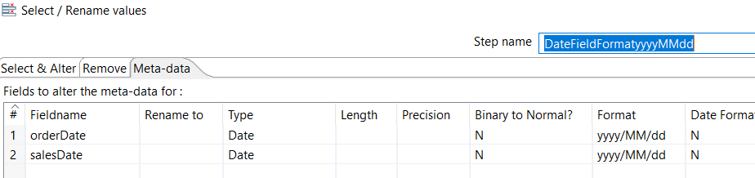

**Figure 41:** Updated field name for consistency.

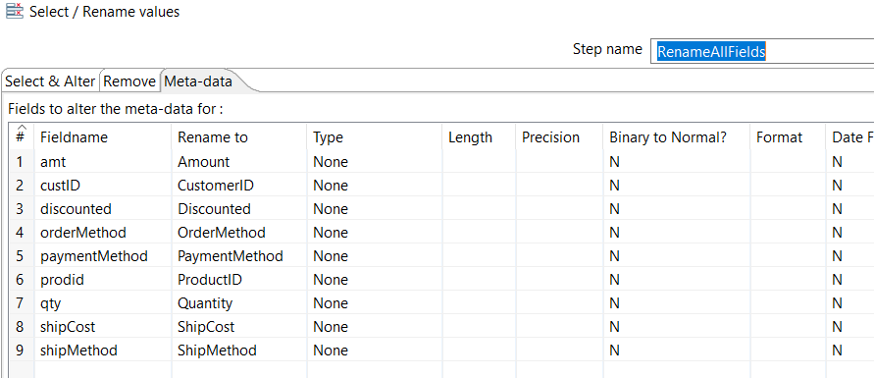

**Figure 42:** Update date field present in salesDate from 200805-16 to 2008/05/16.

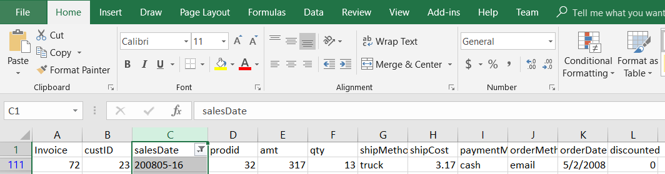

**Figure 43:** Modified wrong custID field and changed each attribute to one cell to the right.

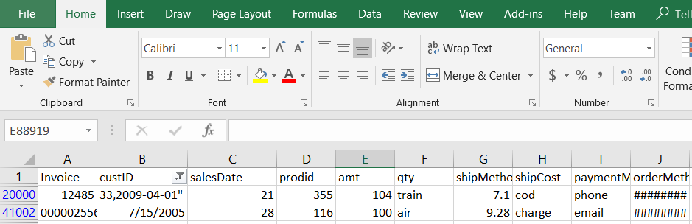

**Figure 44:** Replace ‘tuck’ to ‘truck’ in the shipMethod.

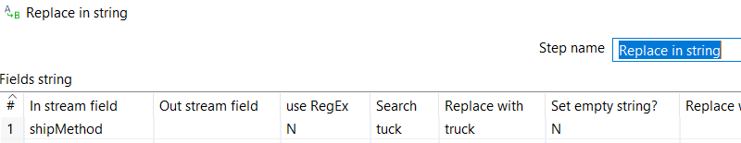

## **2. Data Transformation**

|  |  |
| --- | --- |
| **DM Table** | **Image Creation Process** (attach code) |
| Customer | **Refer to figure 50** |
| Product | **Refer to figure 46, & figure 47** |
| Supplier | **Refer to figure 48** |
| Method | **Refer to figure 45** |
| Date | **Refer to figure 49** |
| Sales_Fact | **Refer to figure 51, figure 52, & figure 53** |

**Figure 45:**  Method Kettle:

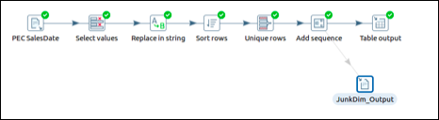

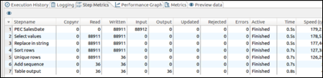

**Figure 46**: Product_Unit_Cost_Calculation Kettle

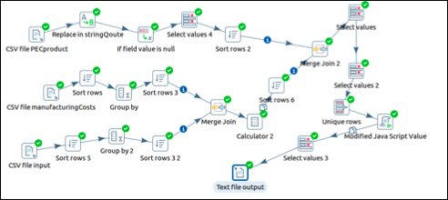

**Figure 47:**  Product Kettle

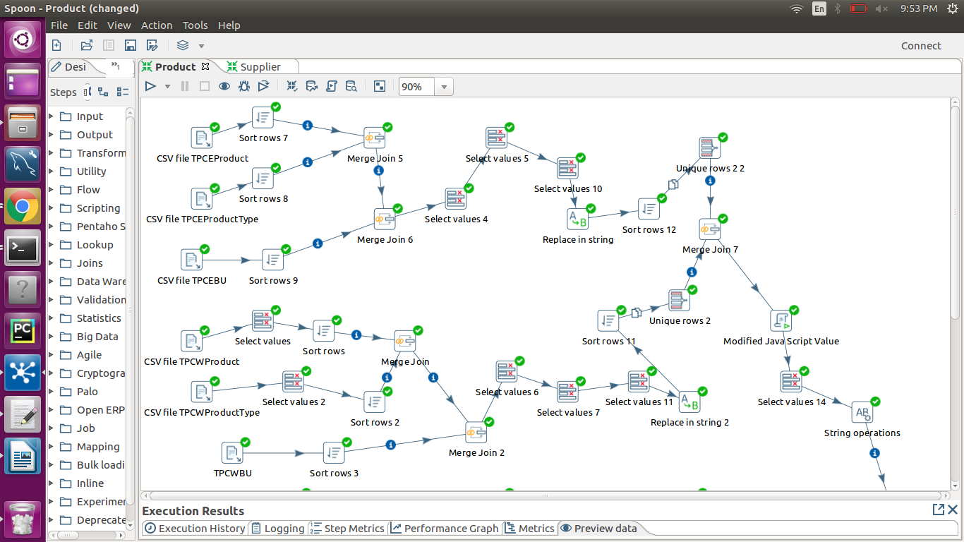

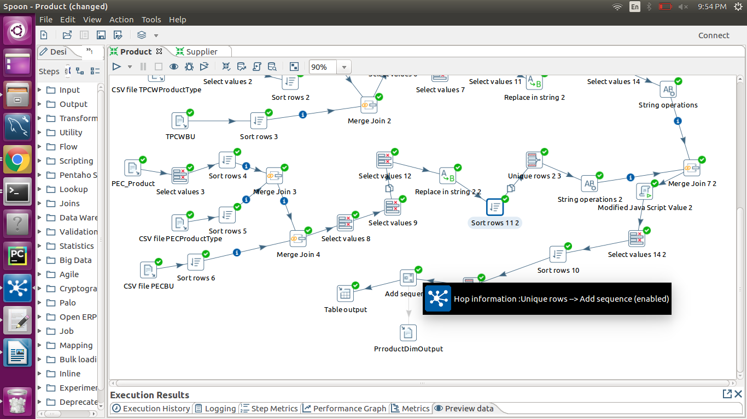

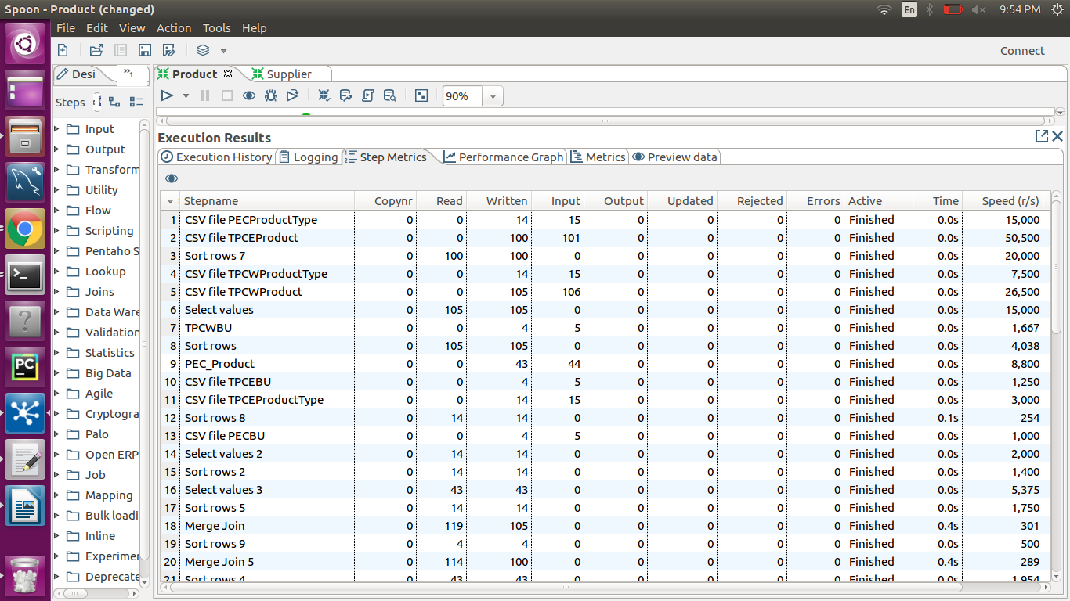

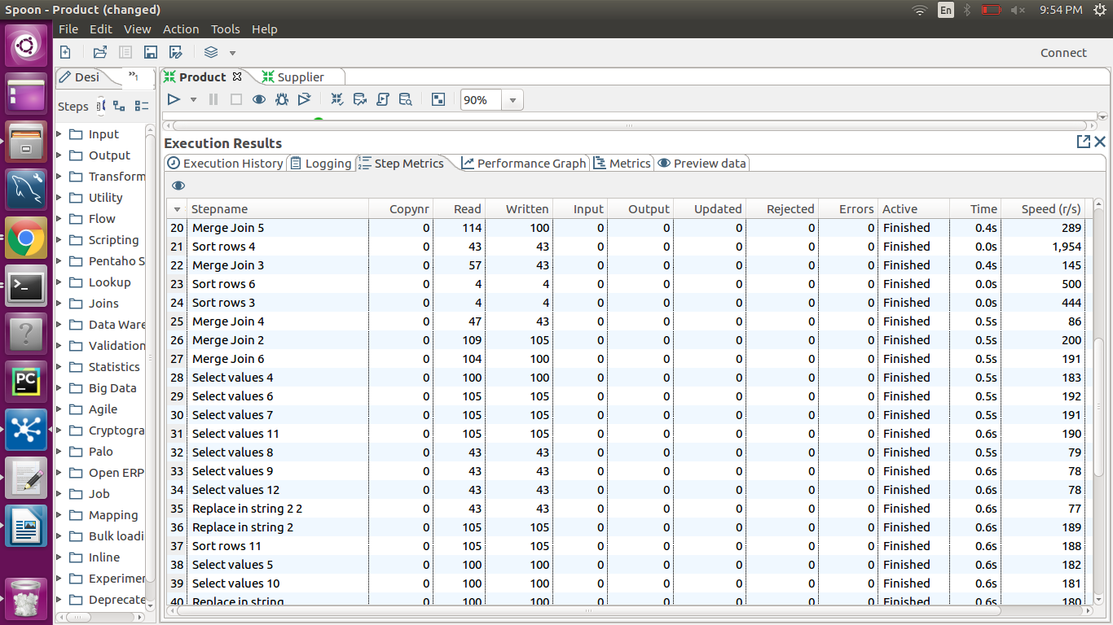

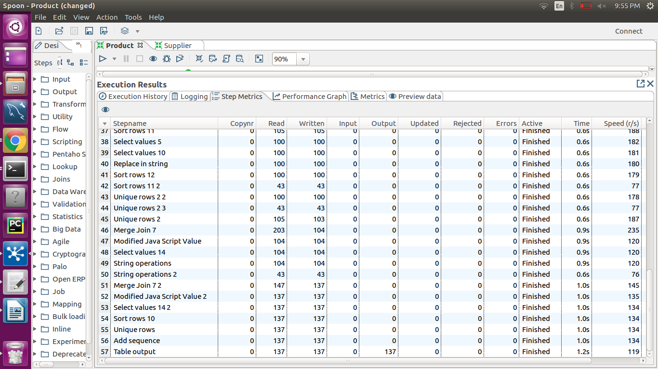

**Figure 48** : Supplier Kettle

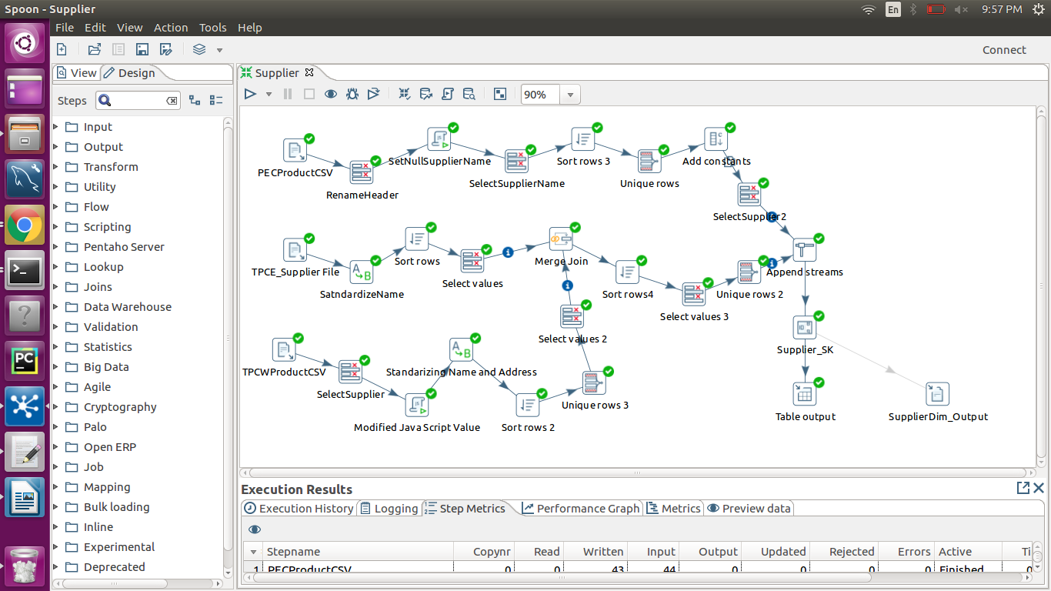

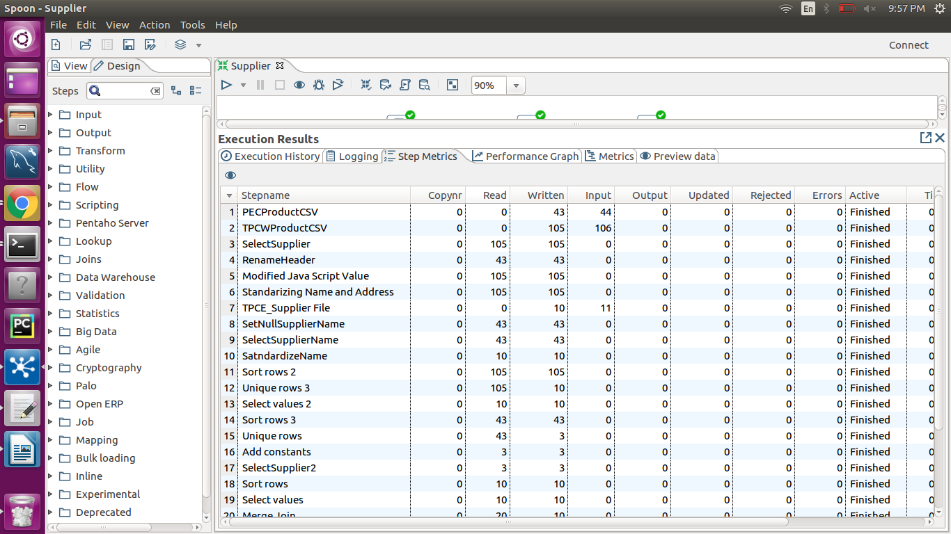

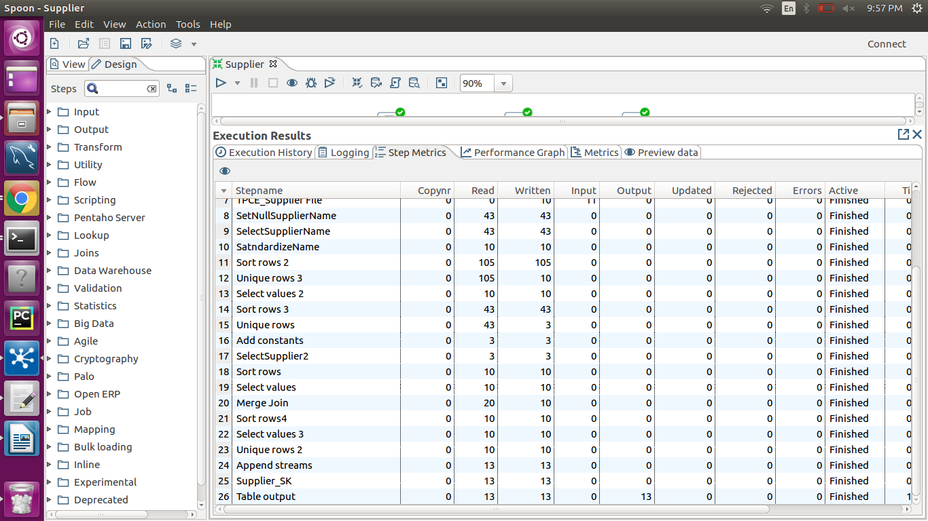

**Figure 49**: Date Dimension

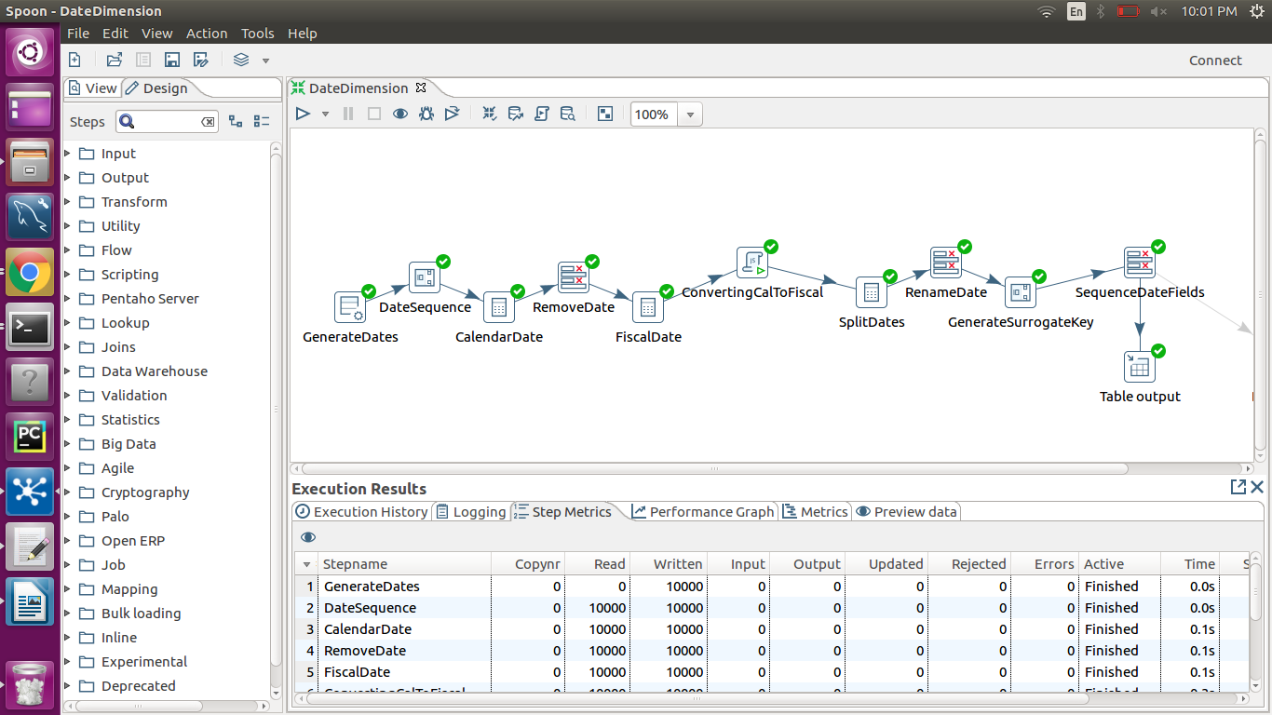

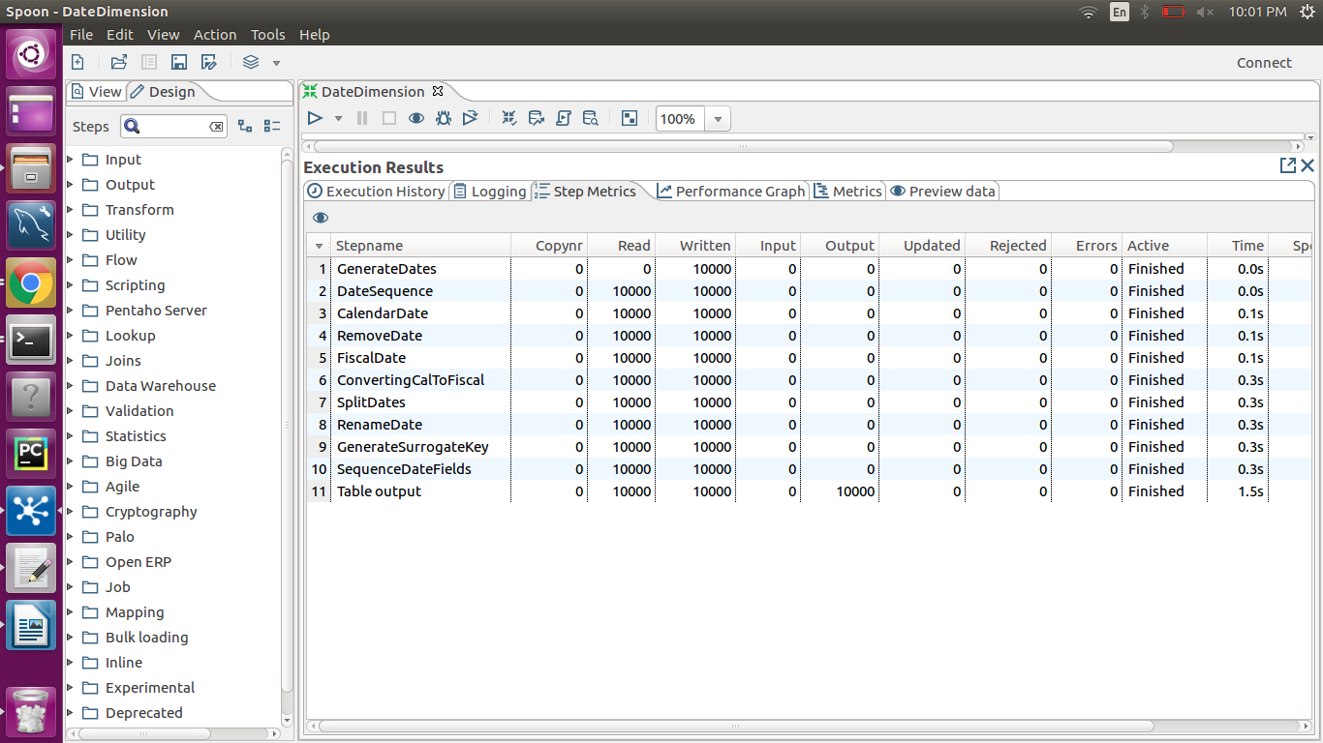

**Figure 50** Customer Kettle

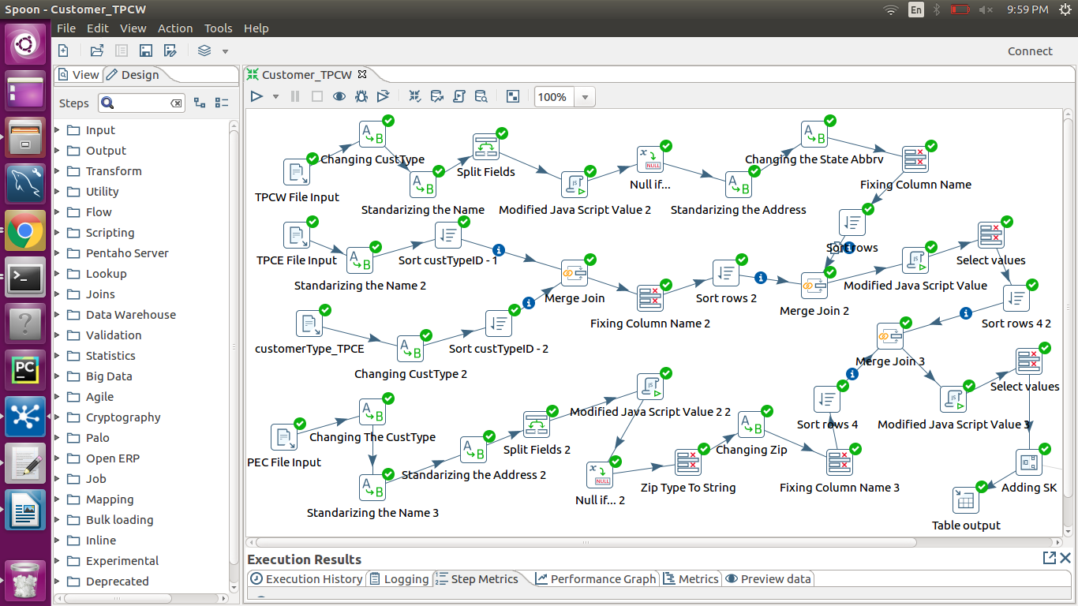

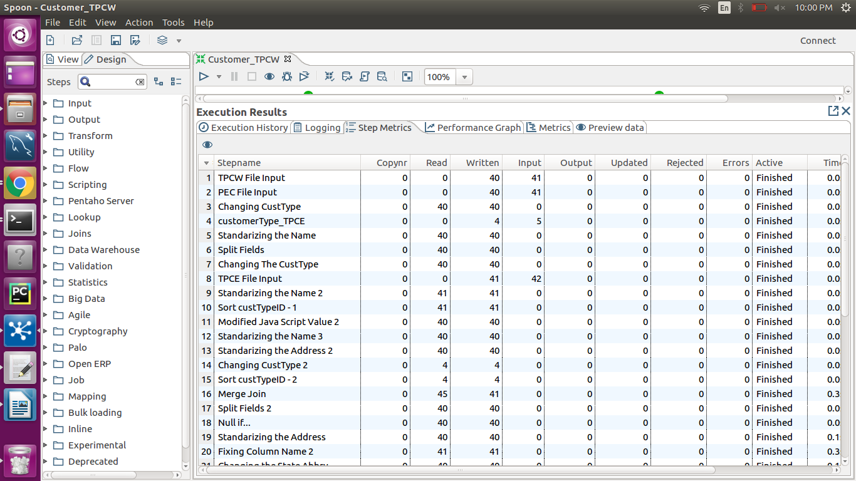

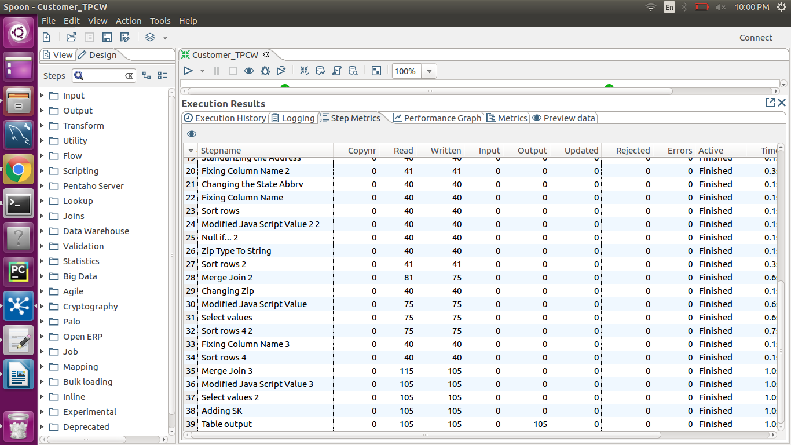

**Figure 51**  PEC Fact Kettle

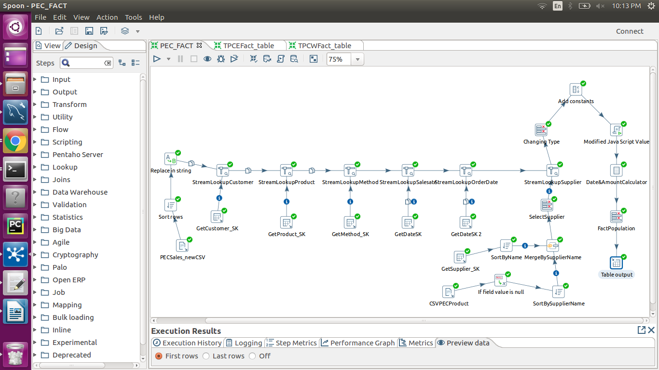

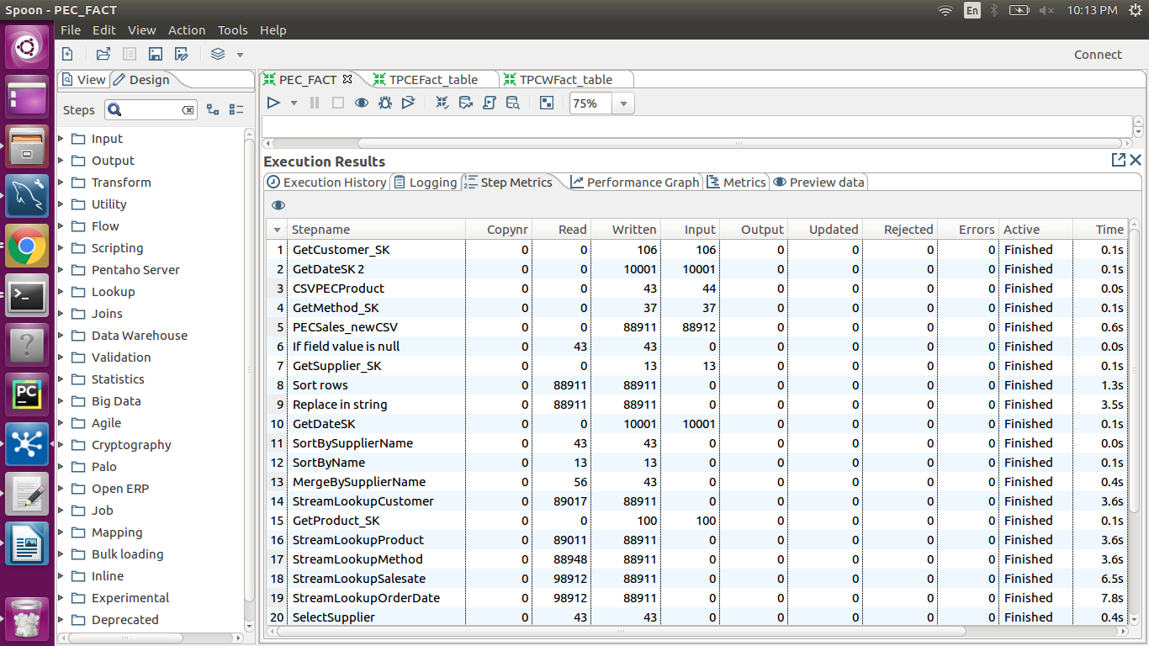

**Figure 52** TPCE Kettle

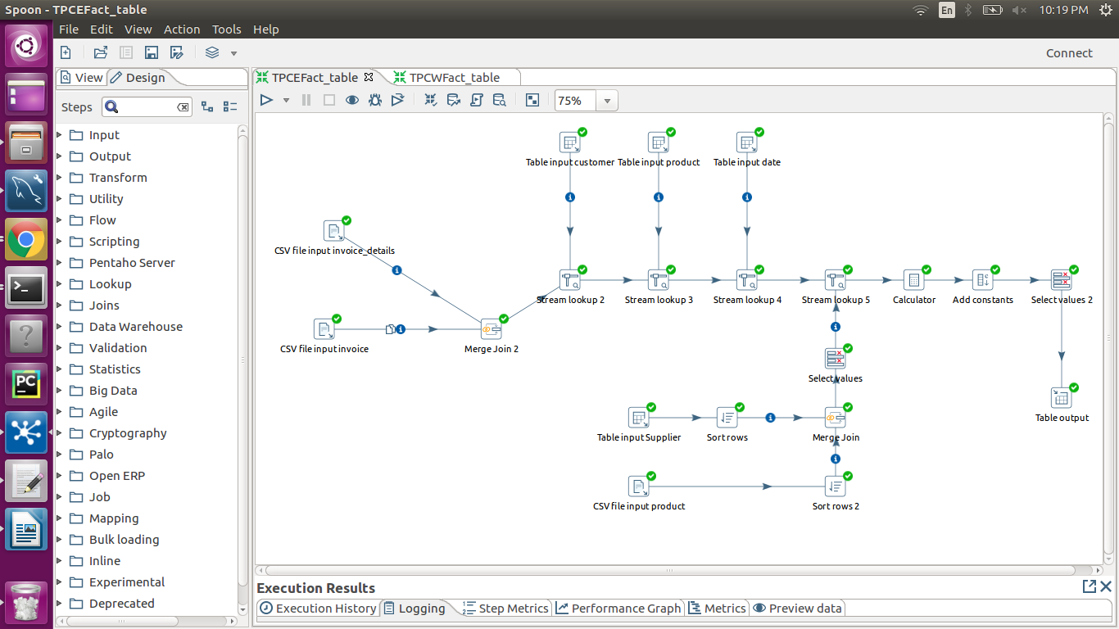

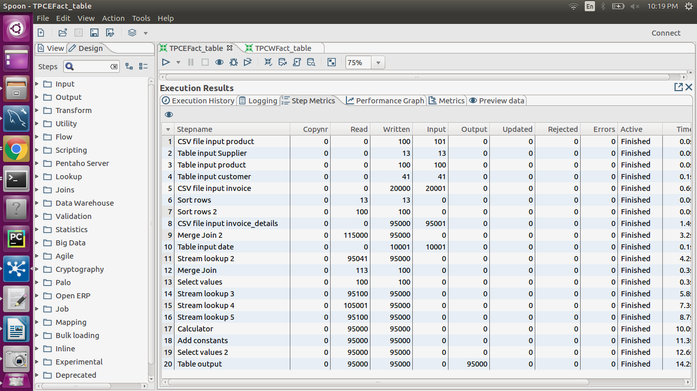

**Figure 53** TPCW Fact

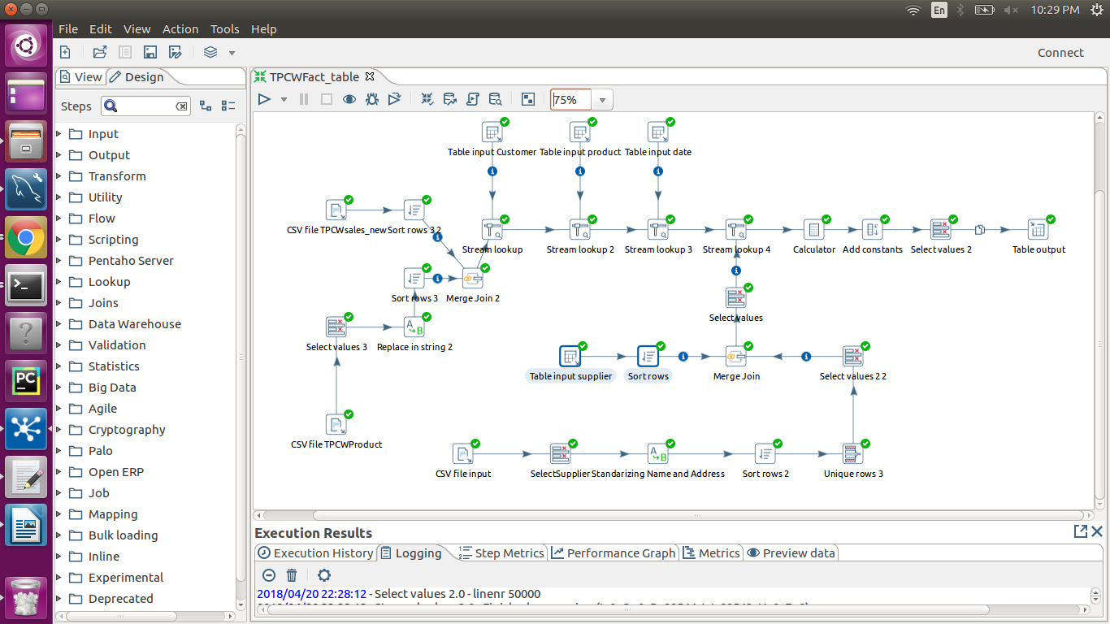

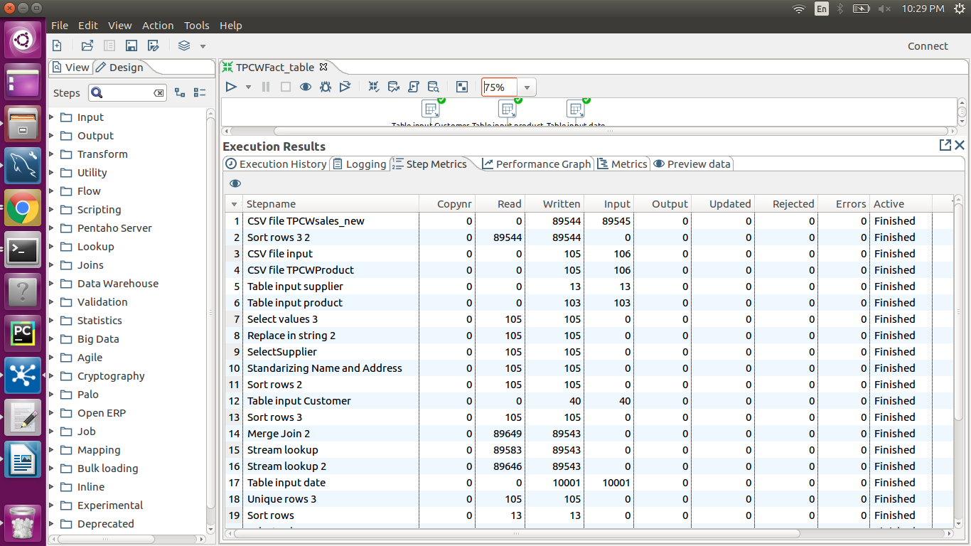

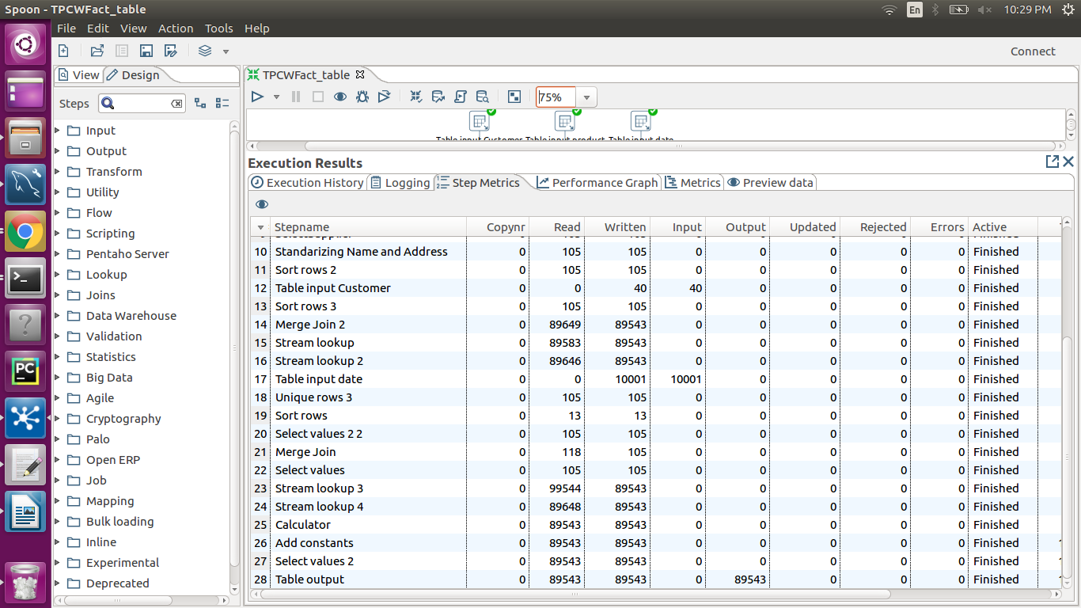

## **3. Table Population**

|  |  |
| --- | --- |
| **DM Table** | **Table Population Process** (attach code) |
| Customer | **Refer to figure 57** |
| Product | **Refer to figure 55** |
| Supplier | **Refer to figure 58** |
| Method | **Refer to figure 56** |
| Date | **Refer to figure 54** |
| Sales_Fact | **Refer to figure 59** |

**Figure 54** Date Loading

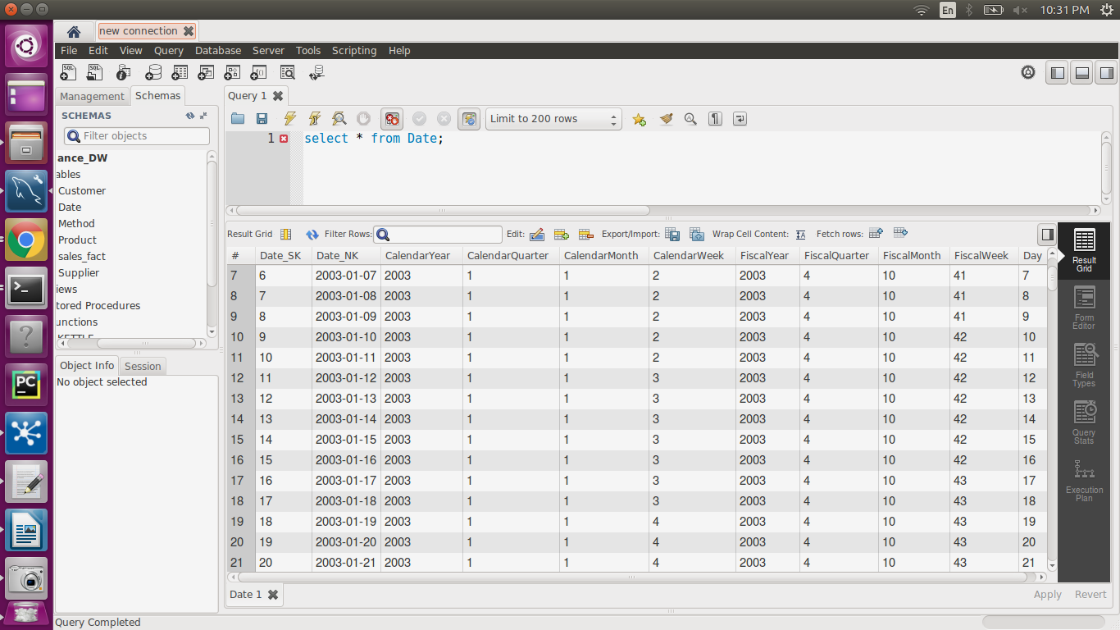

**Figure 55** Product Loading

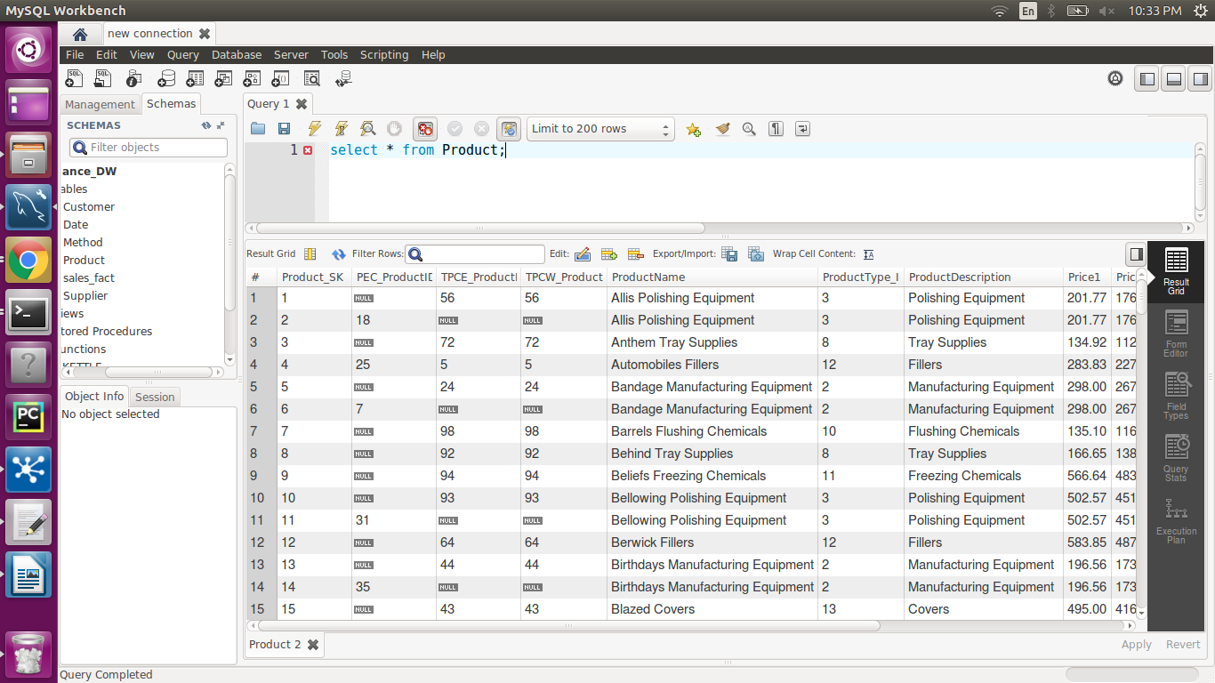

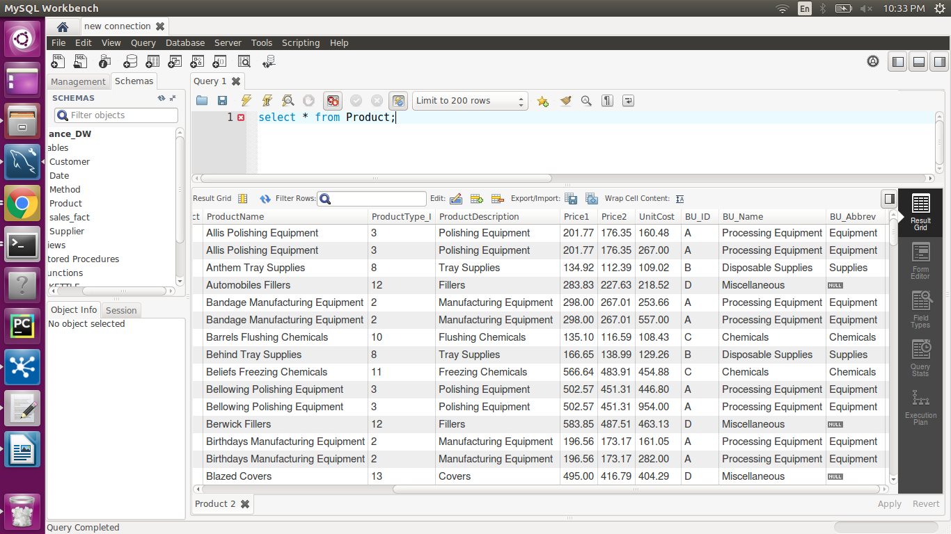

**Figure 56** Method Loading

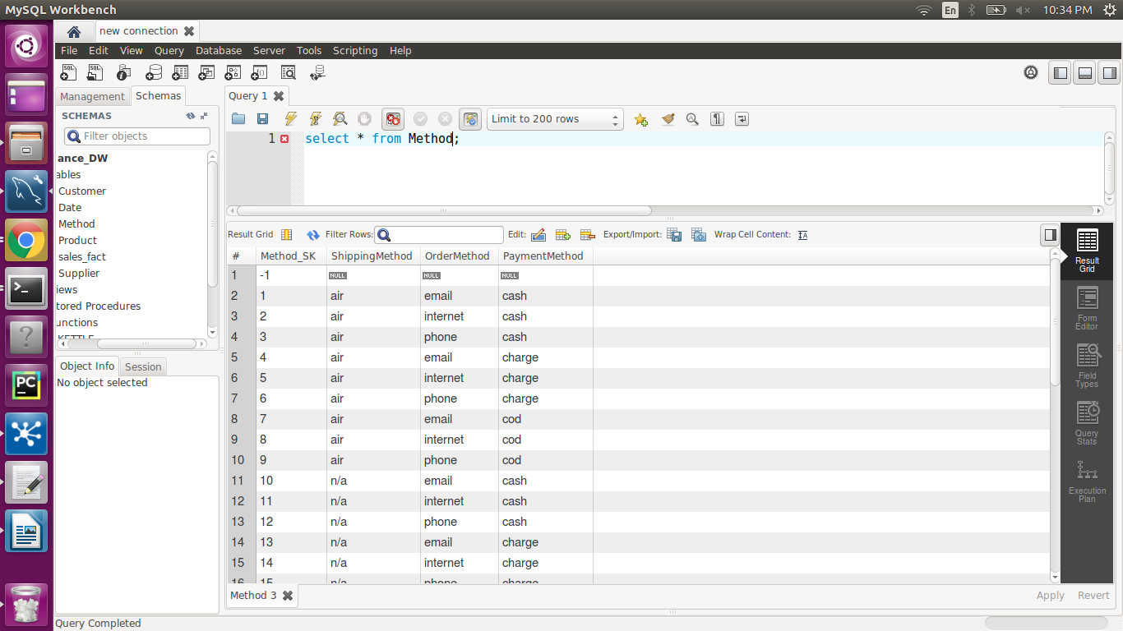

**Figure 57** Customer Loading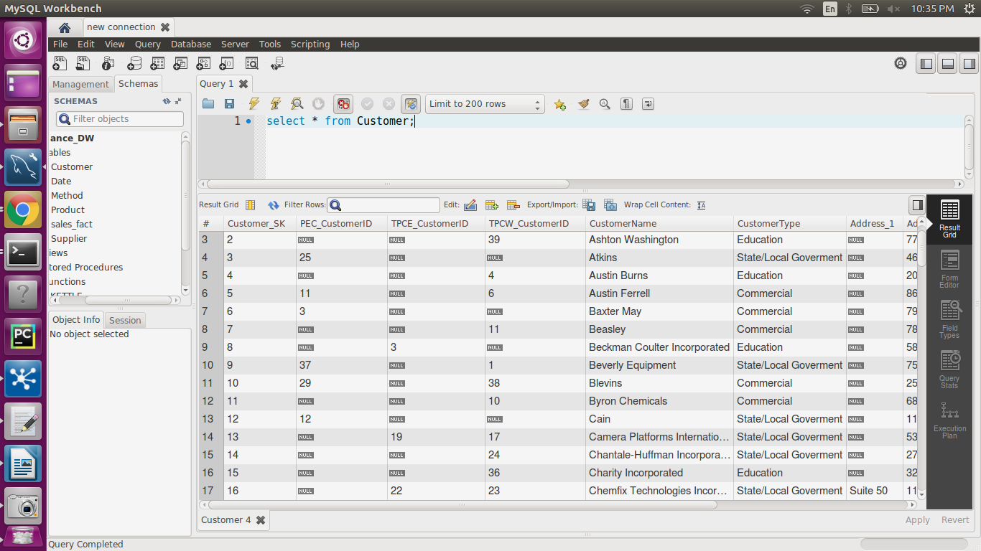

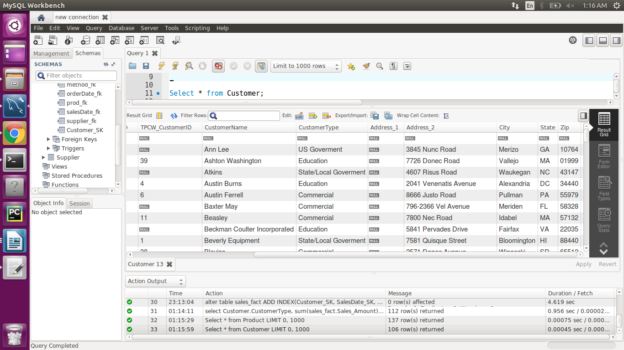

**Figure 58** Supplier Loading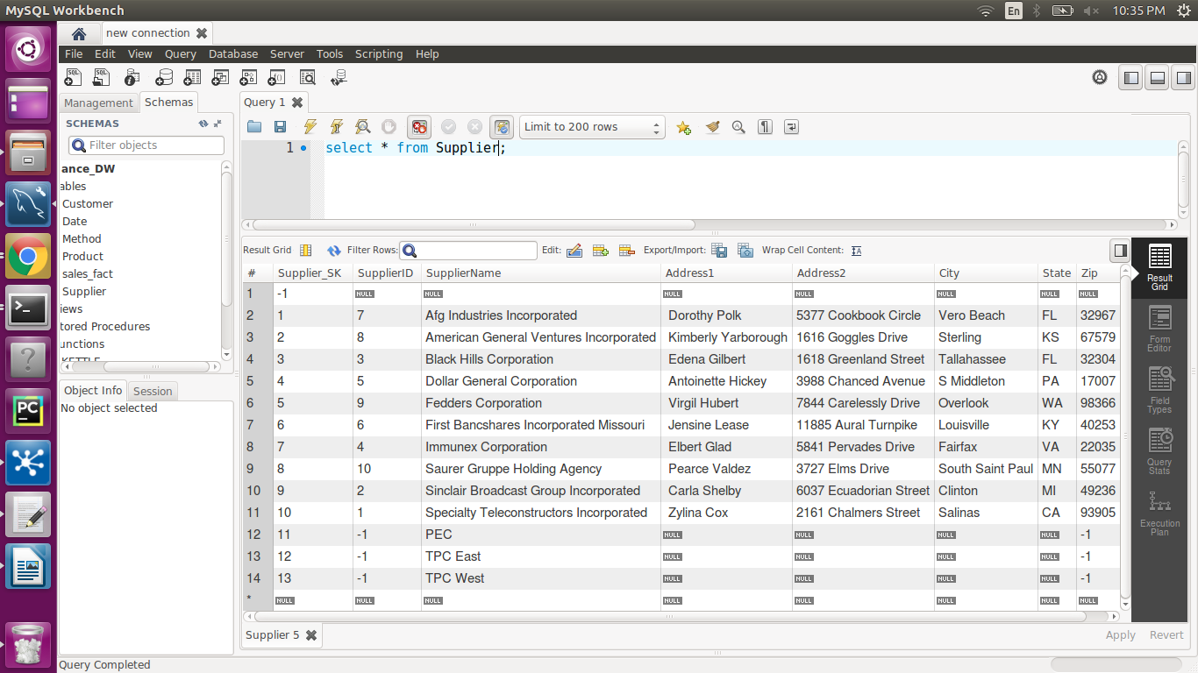

**Figure 59**  Sales Fact Loading

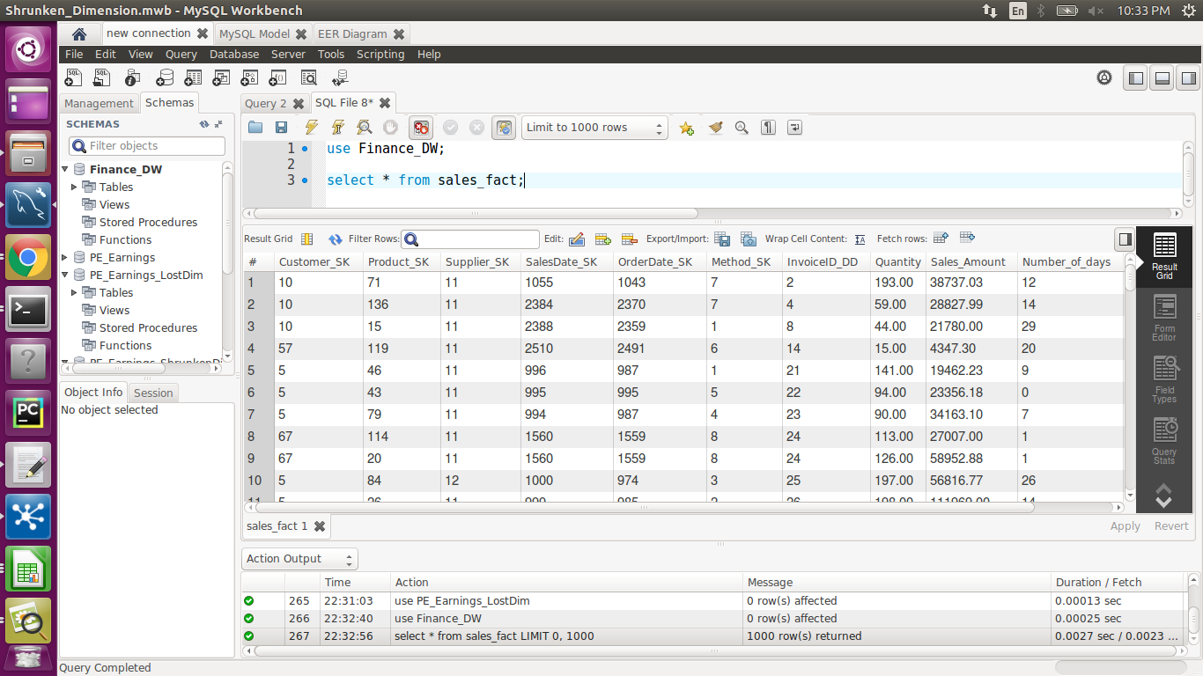

**Figure 60**  Insert Null Values to all dimension

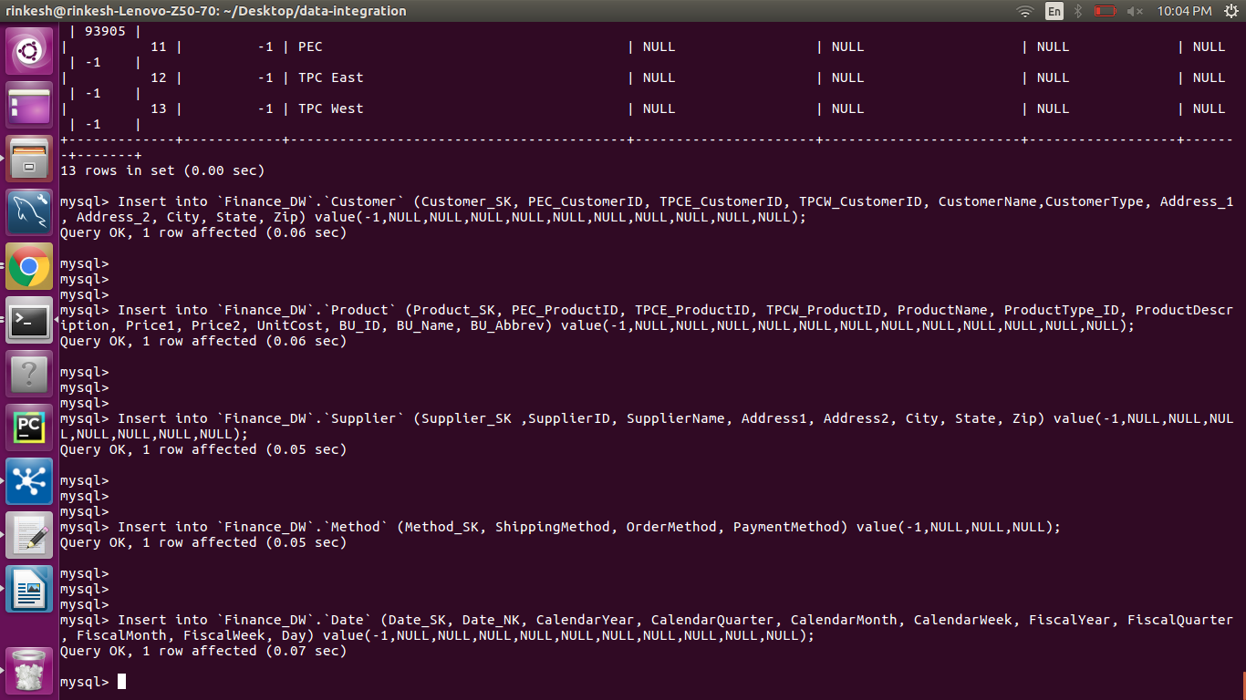

**Figure 61** Insert Foreign Key Constraint

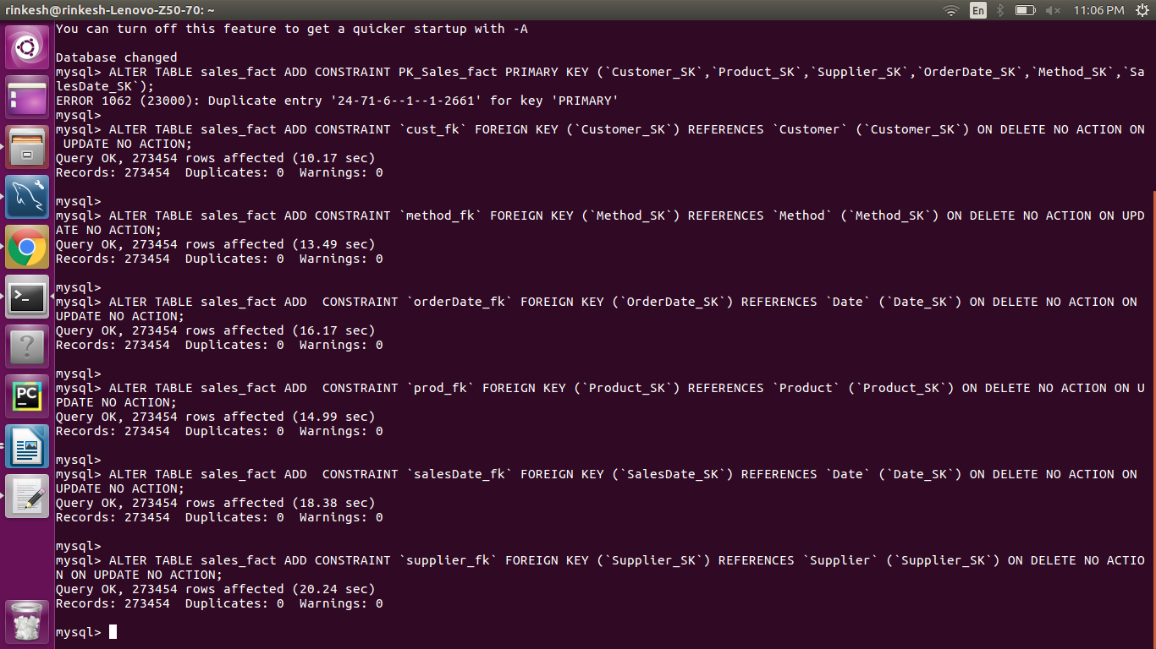

**Figure 62** Creating Indexes

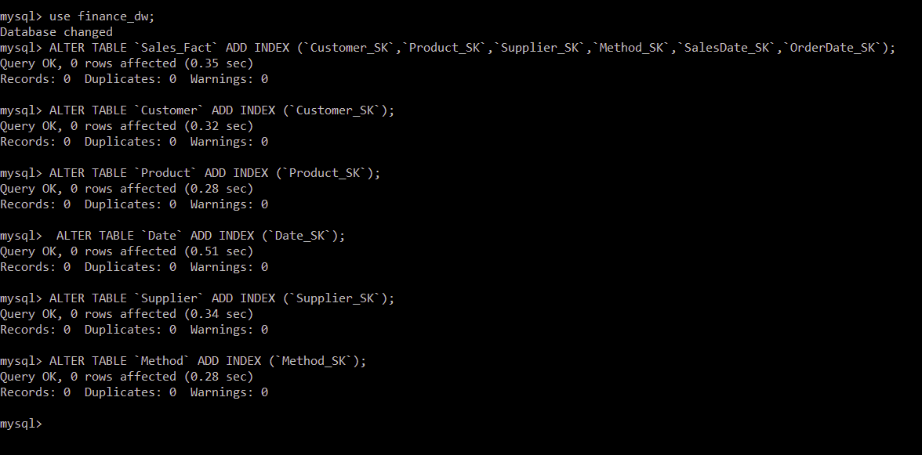

**Query:**

Query Goal: To find the total sales and average number of day to ship to the customer associated with the customer type on quarterly based.

Query:

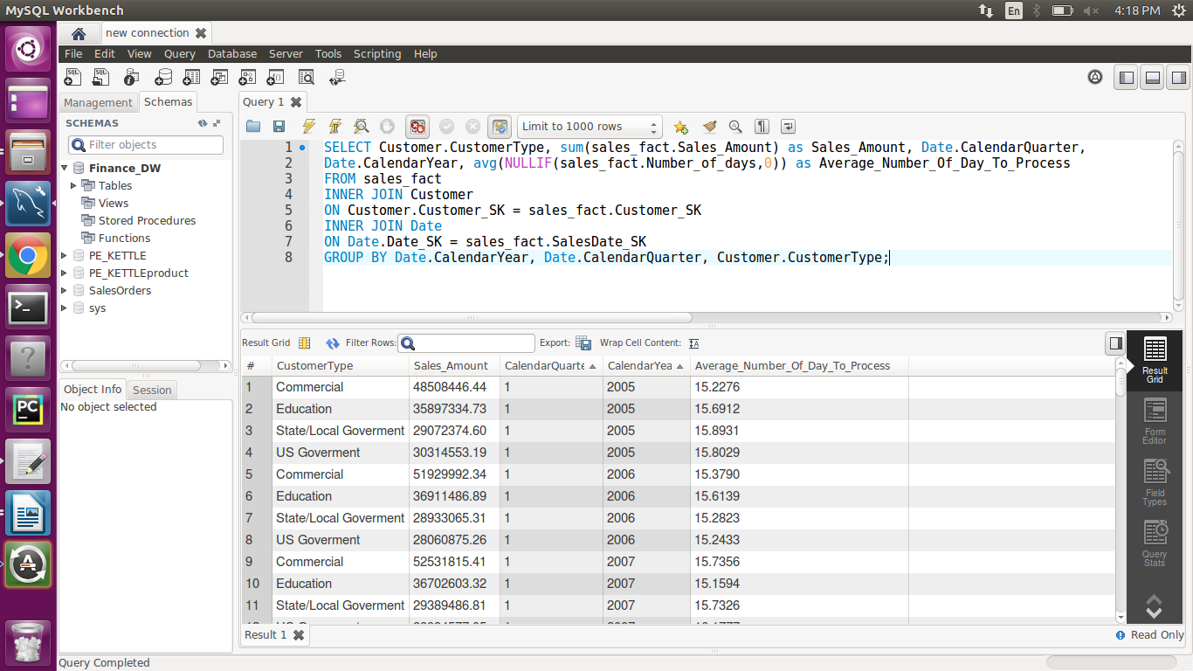

Index: Customer_SK, SalesDate_SK and Date_SK

Output:

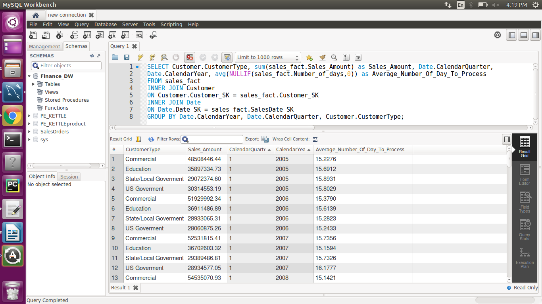

# VII. End User Applications

## **1. Queries**

|  |
| --- |
| **User Question/Reporting Need** |
| The percentage of invoices along with payment method year wise comparison. |
| **SQL Code** |
| SELECT TOTAL_YEAR.CalendarYear, ((COD_COUNT/Total_Count)*100) AS COD_percentage , ((CASH_COUNT/Total_Count)*100) AS CASH_percentage, ((CHARGE_COUNT/Total_Count)*100) AS CHARGE_percentage  FROM (SELECT d.CalendarYear, count(1) as COD_COUNT  FROM Date d  INNER JOIN sales_fact s  ON d.Date_SK = s.SalesDate_SK  INNER JOIN Method m  ON s.Method_SK = m.Method_SK  WHERE m.PaymentMethod = "cod" and s.Method_SK > 0  GROUP BY d.CalendarYear) COD_YEAR,  (SELECT d.CalendarYear, count(1) as CASH_COUNT  FROM Date d  INNER JOIN sales_fact s  ON d.Date_SK = s.SalesDate_SK  INNER JOIN Method m  ON s.Method_SK = m.Method_SK  WHERE m.PaymentMethod = "cash" and s.Method_SK > 0  GROUP BY d.CalendarYear) CASH_YEAR,  (SELECT d.CalendarYear, count(1) as CHARGE_COUNT  FROM Date d  INNER JOIN sales_fact s  ON d.Date_SK = s.SalesDate_SK  INNER JOIN Method m  ON s.Method_SK = m.Method_SK  WHERE m.PaymentMethod = "charge" and s.Method_SK > 0  GROUP BY d.CalendarYear) CHARGE_YEAR,  (SELECT d.CalendarYear, count(1) as Total_Count  FROM Date d  INNER JOIN sales_fact s  ON d.Date_SK = s.SalesDate_SK  WHERE s.Method_SK > 0  GROUP BY d.CalendarYear) TOTAL_YEAR  WHERE COD_YEAR.CalendarYear = TOTAL_YEAR.CalendarYear and CHARGE_YEAR.CalendarYear = TOTAL_YEAR.CalendarYear and  CASH_YEAR.CalendarYear = TOTAL_YEAR.CalendarYear; |
| **Output** |
|  |

|  |
| --- |
| **User Question/Reporting Need** |
| The most frequent method of ordering a product from PEC. |
| **SQL Code** |
| SELECT m.OrderMethod AS FrequentOrderMethod,  COUNT(f.InvoiceID_DD) AS Frequency  FROM sales_fact f  INNER JOIN Method m  ON m.Method_SK = f.Method_SK  WHERE f.Division = 'PEC'  GROUP BY m.OrderMethod  ORDER BY Frequency DESC  LIMIT 3; |
| **Output** |
|  |

|  |
| --- |
| **User Question/Reporting Need** |
| Annual comparison of each supplier by its gross profit from current year to previous year |
| **SQL Code** |
| SELECT a.Year AS Current_Year,a.First_Supplier,a.FirstSup_GrossProfit as Current_Year_Profit,b.SecondSup_GrossProfit as Last_Year_Profit  FROM (SELECT d.CalendarYear AS Year, s.SupplierName AS First_Supplier,   sum(Sales_Amount-Total_Amount) AS FirstSup_GrossProfit  FROM Supplier s, sales_fact f, Date d  WHERE s.Supplier_SK = f.Supplier_SK  AND d.Date_SK = f.SalesDate_SK  GROUP BY d.CalendarYear,s.SupplierName) a  JOIN  (SELECT d.CalendarYear AS Year, s.SupplierName AS Second_Supplier,  sum(Sales_Amount-Total_Amount) AS SecondSup_GrossProfit  FROM Supplier s, sales_fact f, Date d  WHERE s.Supplier_SK = f.Supplier_SK  AND d.Date_SK = f.SalesDate_SK  GROUP BY d.CalendarYear,s.SupplierName) b  WHERE a.First_Supplier = b.Second_Supplier  AND a.Year = b.Year - 1; |
| **Output** |
|  |

|  |
| --- |
| **User Question/Reporting Need** |
| Top five customers each year on the basis of total sales amount. |
| **SQL Code** |
| SELECT count(b.TotalSalesAmount) AS Rank, a.Customer_SK AS CustomerKey, a.CustomerName, a.TotalSalesAmount  FROM (SELECT c.CustomerName, c.Customer_SK, SUM(Sales_Amount) TotalSalesAmount  FROM sales_fact f, Customer c  WHERE f.Customer_SK = c.Customer_SK  GROUP BY c.Customer_SK) a  JOIN  (SELECT c.CustomerName, c.Customer_SK,SUM(Sales_Amount) TotalSalesAmount  FROM sales_fact f, Customer c  WHERE f.Customer_SK = c.Customer_SK  GROUP BY c.Customer_SK) b  WHERE a.TotalSalesAmount <= b.TotalSalesAmount  GROUP BY a.Customer_SK, a.CustomerName  ORDER BY a.TotalSalesAmount desc  LIMIT 5; |
| **Output** |
|  |

|  |
| --- |
| **User Question/Reporting Need** |
| Find the total sales and average number of day to ship to the customer associated with the customer type on quarterly based. |
| **SQL Code** |
| SELECT Customer.CustomerType, sum(sales_fact.Sales_Amount) as Sales_Amount, Date.CalendarYear, avg(NULLIF(sales_fact.Number_of_days,0)) as Average_Number_Of_Day_To_Process FROM sales_fact INNER JOIN Customer ON Customer.Customer_SK = sales_fact.Customer_SK INNER JOIN Date ON Date.Date_SK = sales_fact.SalesDate_SK GROUP BY Date.CalendarYear, Customer.CustomerType; |
| **Output** |
|  |

## **2. Views & Summarization**

|  |
| --- |
| 1. **VIEW NAME: customer_sales_products** |
| The following view facilitates end users to get the total amount spent on the particular type of products by customer. |
| **SQL Code** |
| CREATE  ALGORITHM = UNDEFINED  DEFINER = `root`@`localhost`  SQL SECURITY DEFINER  VIEW `customer_sales_products` AS  SELECT c.CustomerName, p.ProductDescription,sum(f.Sales_Amount) as TotalAmount  FROM sales_fact f, Customer c, Product p  WHERE f.Customer_SK = c.Customer_SK  AND f.Product_SK = p.Product_SK  GROUP BY c.CustomerName, p.ProductDescription;  SELECT * FROM finance_dw.customer_sales_products; |
| **Output** |
|  |

|  |
| --- |
| 1. **VIEW NAME: supplier_product_transactions** |
| The following view facilitates end users to find the sales made by the supplier along with the quantity of the product sold. |
| **SQL Code** |
| CREATE  ALGORITHM = UNDEFINED  DEFINER = `root`@`localhost`  SQL SECURITY DEFINER  VIEW `supplier_product_transactions` AS  SELECT s.SupplierName, p.ProductDescription,sum(f.Total_Amount) as TotalAmount  FROM sales_fact f, Supplier s, Product p  WHERE f.Supplier_SK = s.Supplier_SK  AND f.Product_SK = p.Product_SK  GROUP BY s.SupplierName, p.ProductDescription;  SELECT * FROM finance_dw.supplier_product_transactions; |
| **Output** |
|  |

|  |
| --- |
| **Summary** |
| Summarize the quantity of products sold in every quarter for a particular year. |
| **SQL Code** |
| SELECT d.CalendarYear AS Year, d.CalendarQuarter AS Quarter, p.ProductDescription AS Product, FORMAT(COUNT(Quantity),0) AS Quantity  FROM sales_fact f, Date d, Product p  WHERE f.SalesDate_SK = d.Date_SK  AND f.Product_SK = p.Product_SK  GROUP BY d.CalendarYear,d.CalendarQuarter, p.ProductDescription  WITH ROLLUP; |
| **Output** |
|  |

# III. Handling Slowly Changing Dimensions (SCD)

**SCD TYPE 1 (Overwrite) – On supplier dimension**

Slowly Changing Dimension type 1 is for overwriting existing data, which is present in the table. Generally, these data are erroneous data and occurs because of typo error or wrong information present. Since, these data are error-prone data so there is no need to maintain its history.

As a part of our SCD type1 implementation, we have chosen supplier table. We have assumed that there are some wrong entries (cell values) present in the attribute such as SupplierName, Address1, Address2, City, State, and Zip, which is required to be updated. Below is the screenshot of the supplier_type1 table (the table which we have copied from existing supplier dimension table) before implementation of SCD type1.

**Why-** We have implemented SCD type1 because there is some erroneous attribute value present in the original supplier table which is required to modify. Most of these values have either typo error or have some wrong information which does not require to be preserved.

**Before SCD:** Supplier_type1

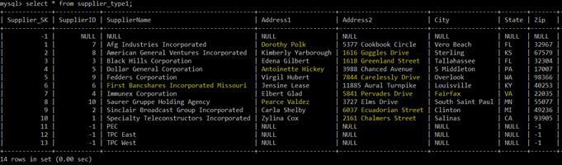

**Implementation (KTR):**

We have created individual SCDInput_Type1.CSV file for updated values. In addition, we have implemented a process in the SCD_Type1.ktr file. The implemented process reads the input CSV file, which has updated attribute value for SupplierName, Address1, Address2, City, and Zip. Followed by this, the process also does a dimension lookup for all the rows based on SupplierID and update the attribute's value. This is achieved by specifying dimension field, stream field to compare with, and type of dimension to update. For the field attribute that is required to update, type of dimension to update has a value of update and for others, it has a value of punch-through. We also need to specify a surrogate key field as a key field. After populating the updated value in the table dimension lookup/update activity creates additional column that contains VersionNum, EffectiveDate, and ExpirationDate, which is not required to maintain as a part of SCD Type1. So, we manually removed these rows using alter table command.

ALTER TABLE supplier_type1 DROP VersionNum, DROP EffectiveDate, DROP ExpirationDate;

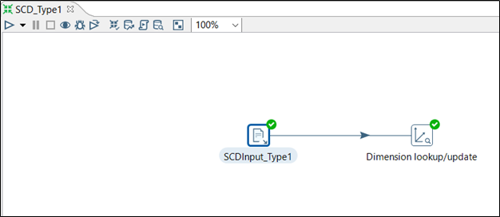

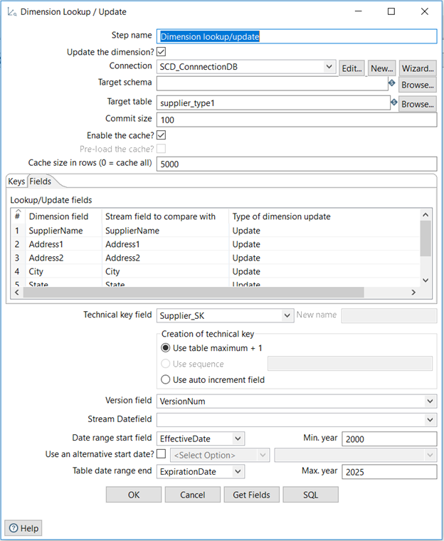

**After SCD:** Supplier_type1

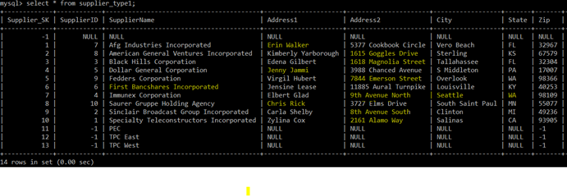

**SCD TYPE 2 (Add a new row) – On product dimension**

**Before SCD:** Product_type2

Slowly changing dimension type 2 is for creating new entries. This happens in the case when an error change has occurred that is relevant to the business rules of DW and it is important to preserve the history of records. Hence, a new row with new surrogate key needs to be entered with the new changes for each of the records. For all the record before changes must reflect the old value and all the record after subsequent changes must reflect a new value. In addition, we have to maintain subsequent version number effective date and expiration date of all the records in this case. For SCD type2 implementation we have chosen product dimension.

**Why-** We have implemented SCD type2 because we assumed that there are some values in the product dimension such as names, descriptions and numeric value have changed. Since the old row value is also important to preserve from the business perspective, so we are implementing SCD type2.

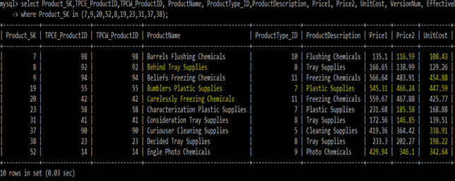

**Implementation (KTR):**

As a part of the implementation, we created a SCDInput_Type2.CSV file that contains changes in the attribute values of ProductName, ProductDescription, Price1, Price2, and UnitCost. Since we have to insert a new row for each record, so we need to specify Type of dimension as an insert for those attributes whose values have been changed rather than update or punch through. For all the other attributes we have to mention punch through in the Type of dimension field. In addition, we need to do a lookup based upon division ids such as TPCE_ProductID and TPCW_ProductID. In the key field, we have to specify a technical key field as Product_SK. For maintaining VersionNum, EffectiveDate, and ExpirationDate we have to specify these fields in the Dimension lookup/update activity. One important thing about Dimension lookup/update activity is that when it finds a change in the record it creates a new record with a new surrogate key, modifies the expiration date of old record and inserts effective date of new record accordingly.

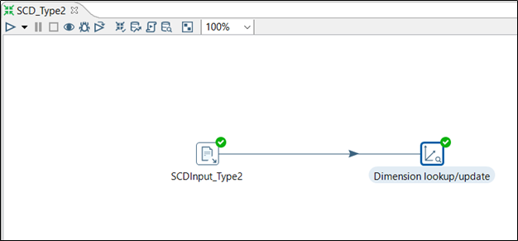

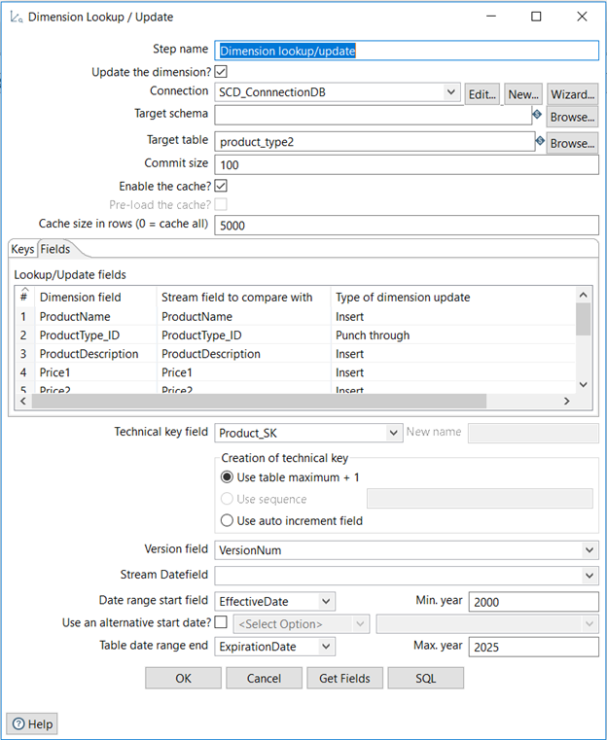

**After SCD :** Product_type2

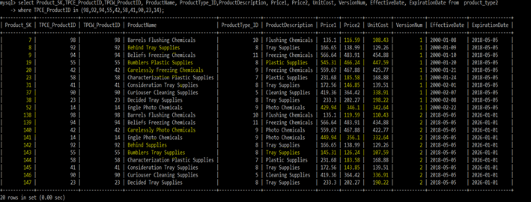

**SCD TYPE 3 (Add New Attribute) – On supplier dimension**

Slowly changing dimension type 3 is for tentative or soft changes. In this case, history before and after a change needs to be preserved. In addition, for each of the subsequence changes all the old values needs to be maintained. Also, sometimes it is required to maintain effective date and expiration date for the new attribute values. However, there is no need to maintain any version number. In SCD type3, only a new column required to add for each attribute changes, so surrogate key remains the same. For our, SCD type3 implementation we have chosen Supplier dimension once again.

**Why-** We have implemented SCD type3 because there is some attribute value present in the original supplier table whose value got changed over time such as supplier name, and addresses. Our assumption of the changes is that may be the supplier organization is acquired by some other organization which is based on some different location.

**Before SCD:** Supplier_type3

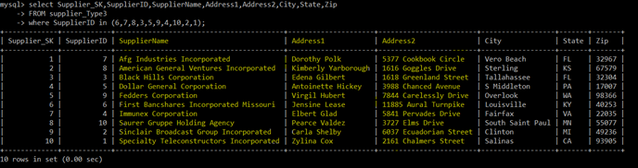

**Implementation (KTR):**

As a part of SCD Type3 implementation, we have created input SCDInput_Type3.CSV file with additional columns for the changed attribute values. We assumed that some suppliers are acquired by the new organization, so their name and address has changed. Hence, we have created three additional column NewSupplierName, NewAddress1, and NewAddress2. In addition, we have maintained EffectiveDate and ExpirationDate that shows when the update happened and till when it is valid. However, we are not maintaining any VersionNum. So, we need to remove the field from the final table. Additionally, We have configured the process to lookup upon SupplierID. Further, for all the old attribute we have configured Type of dimension update field with a punch through whereas for new attribute values we have configured Type of dimension update field with an update. Lastly, we have to configure for EffectiveDate and ExpirationDate fields.

ALTER TABLE supplier_type3 DROP VersionNum;

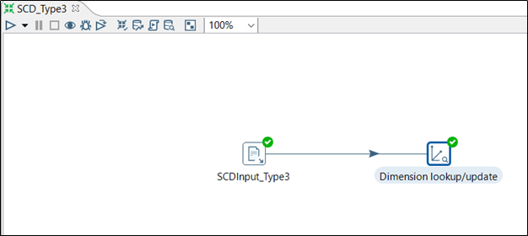

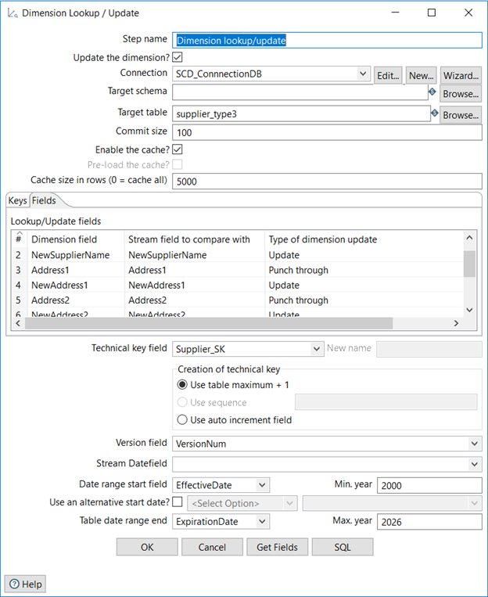

**After SCD:** Supplier_type3

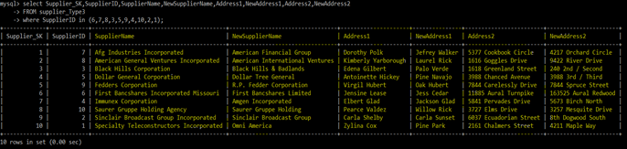

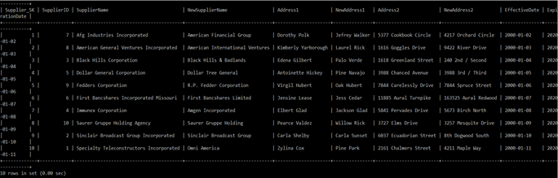

# IX Many-to-Many (N-M) Relationship Implementation Option

**Article Reference : “**I-Y. Song, W.Rowen, C. Medsker, E. Ewen (Dec 27, 2013) ‘An Analysis of Many-to-Many Relationships Between Fact and Dimension Tables in Dimensional Modeling’ from <https://www.researchgate.net/publication/220841965_An_Analysis_of_Many-to-Many_Relationships_Between_Fact_and_Dimension_Tables_in_Dimensional_Modeling> ”

**Design Option:**

* **The Bridge Table:** The table acts as a bridge of both the table (Shipping and Supplier) having many to many relationships, it contains the SK of both the table and the weighting factor. The weighting factor is the percentage that identifies the contribution of both the one SK to another(Shipping to the Supplier). The weighting factor overcomes the problem of N:M in fact table when the aggregation count for each occurrence of a particular SK(Supplier or Shipping). For example, if a Shipping company 'A' occur in two Supplier 'X' and 'Y' then 'A' will be counted twice.
* **Denormalizing the Dimension Table by Positional-Flag Attributes:** It stores a boolean value for a location of each attribute. For instance, if there are five shipping company, then it will contain five different boolean attributes in the table.
* **Denormalizing the Dimension Table by Non-Positional-attributes & a Concatenated Field:** It contains a fixed number of attributes and each attribute store a different shipping company. It also contains a concentrated field which stores all the shipping company in a single attribute
* **Lowering the Grain of the Fact Table:** This stores the Shipping SK and Supplier SK in the fact table which reduce the grain even more. For each event, multiple entries will be stored in the fact table.
* **Lower the Grain of the Fact Table: Separating Diagnosis from Billing Data:** It is similar to above method, but the only difference is it separate the data of shipping company to a different fact table.

We choose the bridge table method, as it is a clean solution than the rest of choice. The size required for storing is also less than most of the dimension. In design choice two there would be a lot more complexity and space when adding a single shipping company, for design 3 there would be a lot of null values in the dimension table. For design 4 and 5, it would increase complexity and size of the fact table. That's why we choose the **bridge table approach.**

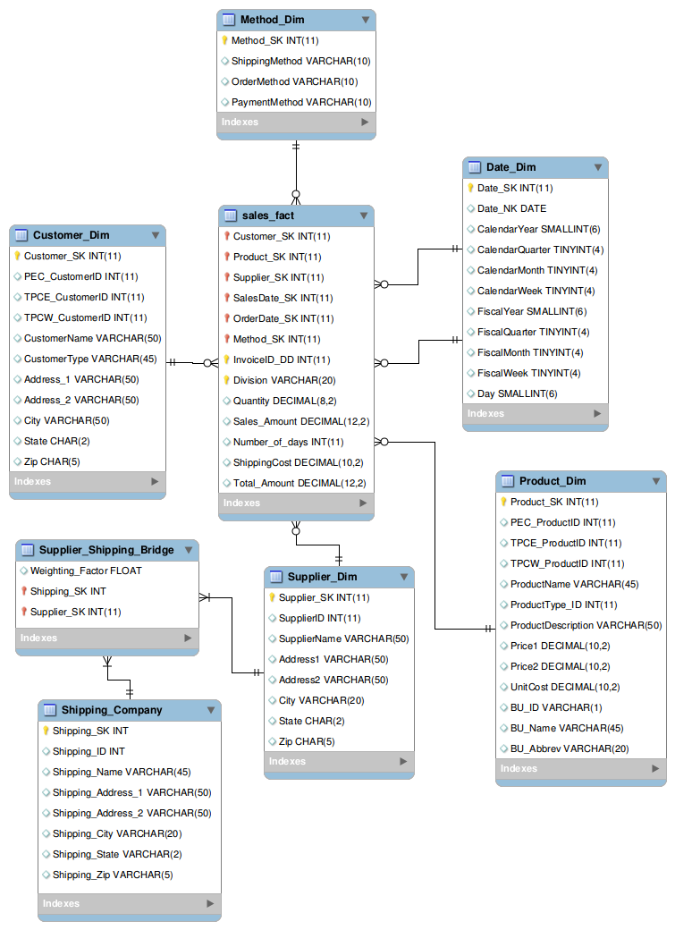

**Fig: N:M ER Diagram using Bridge Table approach**